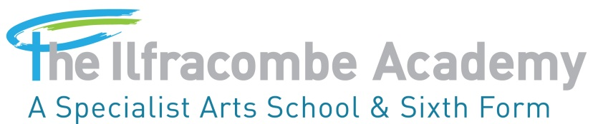
The Academy is committed to excellent Safeguarding

Hope, Kindness, Courage, Integrity, Trust, Respect and Responsibility.

PROVIDER ACCESS POLICY
Policy Date: March 2019 Last updated: October 2021
Date review due: September 2023
Portfolio Group responsible: Curriculum – Jan Gatley
Staff responsible: Steve Cronin – Deputy Headteacher

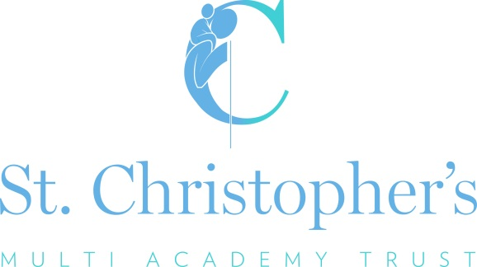

The Ilfracombe Academy: Provider Access Policy

Introduction
This policy statement sets out the school’s arrangements for managing the access of providers to pupils at the school for the purpose of giving them information about the provider’s education or training offer. This complies with the school’s legal obligations under Section 42B of the Education Act 1997.

Pupil entitlement
All pupils in years 8-13 are entitled:
- To find out about technical education qualifications and apprenticeships opportunities, as part of a careers programme which provides information on the full range of education and training options available at each transition point;
- To hear from a range of local providers about the opportunities they offer, including technical education and apprenticeships – through options events, assemblies and group discussions and taster events;
- To understand how to make applications for the full range of academic and technical courses.

Management of provider access requests

Procedure
A provider wishing to request access should contact Richard Vale, Head of Careers.
Telephone: 01271 863427
Email: rvale@ilfracombeacademy.org.uk

Opportunities for access
Below outlines key elements of our careers programme that offer providers an opportunity to come into school to speak to pupils:

 | Year 8 | Year 9 | Year 10 | Year 11 | Sixth Form
Autumn Term |  | Careers Activity – During PCRE lessons –Magistrates, Employment Law  Career Pilot Workshops  Next Steps Day | Assembly – Top Jobs and Opportunities, In demand UK jobs.  Apprenticeships Assembly from PETROC  Next Steps Day | MADE for education study skills day  Sixth Form Recruitment Assembly  Next Steps Day | Young Enterprise Starts  Plymouth University Trip  Next Steps Day
Spring Term | National Careers Week tutorial  University Visit | Year 9 Options Evening Guidance and interviews  Careers Activity Options week – Every Subject careers focus | Petroc Vocational Taster Day  Petroc Taster for Life Skills Students  University Visit – Plymouth | Year 11 Pathways/Sixth form Interviews with SLT  University Presentation in School | National Apprenticeship Exhibition  UCAS Exhibition  Personal Statement writing
Summer Term | Careers Activity - During PCRE lessons -The Real Game (Whole SOW)  CSW Careers Activity During PCRE  Atlas Packaging whole year Enterprise Event | University Visit – Bristol  CSW – Impartial Careers Guidance – Selected students.  Careers Activity – During tutorial – A SOW of six tutorials | Assembly – Labour Market Information  Careers Activity – During Tutorial – CV Writing.  Your Hired – Careers Event  Year 10 Work Experience Week |  | CSW – Impartial Careers Guidance –  University Trip - Falmouth and Cardiff

Please speak to our Head of Careers to identify the most suitable opportunity for you.

Premises and facilities
The school will make St Christopher’s Hall, classrooms or private meeting rooms available for discussions between the provider and students, as appropriate to the activity. The school will also make available AV and other specialist equipment to support provider presentations. This will all be discussed and agreed in advance of the visit with the Careers Leader or a member of their team.

Grounds for granting and refusing access
All requests are on a case by case basis, we really value any support with our careers programme. A large part of our careers offer is the annual Next Steps Day and You’re Hired events that depend on local business and education providers.

Policy History

Policy/Version Date | Summary of change | Contact | Implementation Date | Review Date
March 2019 | New policy | S Cronin | March 2019 | Sept 2020
April 2019 | Updated | J Gatley | April 2019 | April 2020
April 2020 | Updated – Covid19 | S Cronin | April 2020 | April 2021
October 2020 | Updated – Covid19 | S Cronin | October 2020 | September 2021
Nov 2021 | Update – New careers lead | S Cronin | November 2021 | September 23

