Data Protection Handbook
This handbook brings together a number of policies into one place for ease of access. Please note each area below is hyperlinked for your ease of access. If you have any queries or if there is anything not covered in this policy please contact the school’s Data Protection Officer i-west@bathnes.gov.uk
Note: Our Social Media Policy – (Created December 2016) continues as a separate policy and has not been incorporated into this handbook

1. Data Protection and Handling Policy Page 2
Subject Access Procedures Page 6
Data Security Procedures Page 7
Sending a secure email Page 8
Setting up an email delay Page 8
Disabling email notification alerts Page 9
Receiving a Reference Request Page 9
2. Data Breach Policy Page 10
Incident Reporting Form Page 13
Record of work Form Page 14
3. Special Categories of Personal Data Policy Page 16
4. Internet Safety Policy Page 19
5. Acceptable Usage Agreement – Students Page 24
6. Acceptable Usage Agreement – Parents Page 26
7. Acceptable Usage Agreement – Workforce Page 27
8. Acceptable Usage Agreement - Guest Wireless Access Page 29
9. Acceptable Usage Agreement – Student Wireless Access Page 30
7. Search Policy – Electronic Devices Page 31
8. Data Retention & Disposal Policy Page 32
What is Confidential Waste Page 33
What happens when a student/member of staff leaves Page 34
Retention Schedule (how long to keep records for) Page 35-54
The Board of Directors is responsible for this Handbook
Newly Created: May 2018 (replacing previous e safety suite of policies)
Last updated: June 2019
Review date: June 2020 (each component)
Portfolio Group Responsible: SEN and Safeguarding, and Community

Data Protection and Handling Policy
The school uses personal information to educate our students and fulfil our statutory obligations. We take data protection very seriously and all members of staff will do everything in their power to keep personal information secure.
Anyone with access to personal data must follow the principles set out below. The policy combines requirements from data protection legislation with other relevant guidance. Members of staff who handle personal data should familiarise themselves with these regulations as well as the school’s policy.
Personal Data
The Data Protection Act defines “Personal Data” as data relating to a living individual who can be identified from those data or from other information held by, or likely to come into the possession of, the data controller.
The school holds a range of personal data (including personal information about members of the school community, professional records of staff members and academic information) in digital form and as paper records.
Data Protection Principles
Under the Data Protection Act 2018 and the General Data Protection Regulation, data controllers must adhere to the following six principles. Personal data should be:
- processed lawfully, fairly and in a transparent manner in relation to individuals;

- collected for specified, explicit and legitimate purposes and not further processed in a manner that is incompatible with those purposes; further processing for archiving purposes in the public interest, scientific or historical research purposes or statistical purposes shall not be considered to be incompatible with the initial purposes;

- adequate, relevant and limited to what is necessary in relation to the purposes for which they are processed;

- accurate and, where necessary, kept up to date; every reasonable step must be taken to ensure that personal data that are inaccurate, having regard to the purposes for which they are processed, are erased or rectified without delay;

- kept in a form which permits identification of data subjects for no longer than is necessary for the purposes for which the personal data are processed; personal data may be stored for longer periods insofar as the personal data will be processed solely for archiving purposes in the public interest, scientific or historical research purposes or statistical purposes subject to implementation of the appropriate technical and organisational measures required by the law in order to safeguard the rights and freedoms of individuals;

- processed in a manner that ensures appropriate security of the personal data, including protection against unauthorised or unlawful processing and against accidental loss, destruction or damage, using appropriate technical or organisational measures.

General Statement
We are fully committed to upholding the above principles and will:
- Inform individuals why personal information is collected.
- Notify individuals when their data is shared and explain why and with whom it was shared.
- Maintain the quality and accuracy of personal data.
- Not retain information for longer than necessary.
- Destroy any information that is no longer needed appropriately and securely.
- Protect all personal information from loss, theft and unauthorised disclosure.
- Share information with others only when legally appropriate.
- Set out procedures to ensure compliance with Subject Access Requests.
- Make sure all staff are fully aware of our policies.

Responsibilities
The school’s Data Protection Officer can be contacted by emailing i-west@bathnes.gov.uk
The school links to our DPO via the Office Manager and the Headteacher’s PA.
Registration
We are registered as a data controller on the Data Protection Register held by the Information Commissioner. Our registration number is Z9640844
“Fair Processing Notice or Privacy Notice” – Information for Parents and Carers
In compliance with the fair processing requirements of the General Data Protection Regulation (GDPR) and the Data Protection Act 2018, we keep parents and carers informed about the student data we collect, the purposes for which it is held and any third parties with whom it may be shared. This fair processing notice (commonly referred to as a privacy notice) is available on the school website and other publications.
Training
All staff receive guidance in data protection and handling. They will be made aware of their responsibilities following appointment and as outlined in this policy
Storage and Access
Our ICT systems include security measures to prevent unauthorised users from accessing protected files. All users are assigned a role and clearance which will determine their access to protected data.
Users must set strong passwords, change them regularly, and never share them. Personal data will only be accessed from password protected devices which should be locked when not in use. We will take appropriate steps to keep data storage media physically secure.
Our Data Security Procedures (See Appendices C to E) set out how staff should secure personal data.

Data Subject Rights and Subject Access Requests
Data subjects have a number of rights under the Data Protection Act:
- The Right to be informed in a clear, concise and transparent manner

- The Right of access

- The Right to rectification

- The Right to erasure

- The Right to restrict processing

- The Right to data portability

- The Right to object

- Rights related to automated decision making

Data will be made available to a ‘data subject’ following a written request to the Headteacher. It is generally understood that students over the age of 12 can make their own requests, dependent on their capacity and understanding of their information rights. The student will be consulted if parents make requests on their behalf, taking into account the previous sentence in regards to age and capacity. Data subjects may request:
- To know if the school holds personal information about them
- A description of any data held
- The purpose for which the data is processed
- The sources of the data
- To whom the data may be disclosed
- A copy of all their personal data.

Appendix A of this policy – sets out our procedures for processing Subject Access Requests.
Data Transfers and Remote Access
It may sometimes be necessary to transfer personal data to the local authority or other agencies, or for members of staff to access personal information outside of school. In these cases:
- Users must have permission to access or transfer the data out of school and use appropriately secured media/devices
- Devices containing personal data may only be accessed by authorised users
- Where possible, personal data should be accessed via secure remote access to the school’s management information system
- Users should securely store and protect any personal devices used to access data.

The local authority and Data Protection Officer should be consulted if it is necessary to transfer data to another country.
Retention & Disposal
We keep personal data for no longer than is necessary – these timeframes and disposal requirements are detailed in our Data Retention & Disposal Policy.

Data Protection by Design

It is a statutory requirement that any activity involving a high risk to the data protection rights of the individual when processing personal data be assessed by the Data Protection Impact Assessment. Prior to the assumption of any such activity i-west must be consulted and an initial screening be conducted assessing risk.
Any activity involving the processing of personal data must be registered on the Register of Processing Activity and reviewed at the very least annually.

Data Breaches and Security Incidents

Wherever it is believed that a security incident has occurred or a ‘near miss’ has occurred, the school and the Data Protection Officer (i-west) must be informed immediately and the Security Incident Management (SIM) process must be carried out. The SIM is designed to manage, investigate, report and provide ‘Learning from Experience’ (LFE) to avoid future incidents occurring.

In any case an incident must be reported no later than 24 hours from identification, except where a malicious incident has occurred. The learning culture within the school seeks the avoidance of a blame culture and is key to allowing individuals the confidence to report genuine mistakes.

Further details on security incidents and data breaches can be found in the Data Breach Policy
Appendix A – Subject Access Request (Procedures)

The school shall complete the following steps when processing a request for personal data (Subject Access Request or SAR) with advice from its Data Protection Officer (i-west).

- Ascertain whether the requester has a right to access the information and capacity.

- Obtain proof of identity (once this step has been completed the clock can start)

- Engage with the requester if the request is too broad or needs clarifying

- Make a judgement on whether the request is complex and therefore can be extended by a further 2 months

- Acknowledge the requester providing them with
  - the response time – 1 month (as standard), an additional 2 months if complex; and
  - details of any costs – Free for standard requests, or you can charge if the request is manifestly unfounded or excessive, or further copies of the same information is required, the fee must be in line with the administrative cost

- Use its Record of Processing Activities and/or data map to identify data sources and where they are held

- Collect the data (the school may use its IT support to pull together data sources)

- If (6) identifies third parties who process it, then engage with them to release the data to the school

- Review the identified data for exemptions and redactions in line with the ICO’s Code of Practice on Subject Access and in consultation with the school’s Data Protection Officer (i-west).

- Create the final bundle and check to ensure all redactions have been applied

- Submit the final bundle to the requester in a secure manner and in the format they have requested.

Appendix B – Data Security Procedures
All consumers must protect personal data:
- By Locking screens when away from their desks (using +L)
- By disposing of information and equipment in an appropriate manner:
  - Equipment – via the school’s accredited provider
  - Paper – using either a cross cut shredder or the school’s accredited provider which may be facilitated by Confidential Waste receptacles.
- Ensuring special categories of personal data¹ is given extra security, and at a minimum is locked away when not in use (¹ See Special Categories of Personal Data Policy)
- Using encryption when processing personal data offsite e.g. working at home (either on an encrypted device or an encrypted USB stick owned by the school). For encrypted sticks users must
  - ensure the information is uploaded back to the school’s network as soon as possible;
  - only process the data on the stick and not process or save the data outside of the stick (e.g. locally to the device).
- When processing data on an unmanaged (personal device) users must ensure:
  - The device is protected by PIN, Password or fingerprint, and ideally encrypted
  - That the school’s systems (e.g. Webmail) are not left logged in
  - That attachments are not opened (and downloaded), unless in an emergency where measures are to be taken to delete the information after use
- Data taken offsite must be protected at all times, as well as the above, users must:
  - Keep information and equipment on their person at all times (e.g. when stopping off on the way home)
  - Be held in an appropriate receptacle (e.g. bag) to reduce the risk of opportunistic theft
  - Not store or leave the information and equipment in a vehicle when not in use
  - Consider whether data minimisation could be used. For example:
    - Not making the information personally identifiable, by using pseudonymisation (e.g. Unique reference or initials)
    - Using a code system or colour code system to identify key indicators (e.g. allergies)
    - Not having the school logo on any hardcopy documents
    - Using encryption to protect the data (e.g. encrypted device rather than hard copies)
- Ensuring care is taken with emails, by applying the following:
  - Was I expecting this email? And does it look and feel right?
  - Can I check (by other trusted means) that the email is legitimate?
  - Not clicking any links or opening any attachment with validating them
  - Disabling pop-up notifications for new incoming emails (See Appendix E)
  - Using blind copy (BCC) when emailing more than one external user
  - Double checking the email address when sending emails
  - Encrypting personal data to external addresses (See Appendix C)
  - A one minute email delay rule is in place on all emails sent, this provides a safety net where all emails sent are held in Outbox for one minute before delivery allowing the user to edit/delete (See Appendix D)
- Ensuring any information disclosed verbally is
  - Validated – the person calling/present is known to have the need to know
  - Documented – a summary of what was disclosed and filed
- Ensuring any information sent via post has the address double checked – where possible copy and paste from a system and is marked Private & Confidential
- It is essential that you use SIMS as your data source for contact details as this is our primary management information system where up to date contact details will be maintained.
Appendix C – Securing an email in transit
The three main risks associated with email are:
- Emails are intercepted in transit
- Emails are sent to the wrong recipient
- Email addresses are disclosed to those without the need to know
This process covers risk (1) and enables the secure exchange of information over email (in the absence of a secure email portal).
- Document the information in an MS Office document
- Ensure that this is not the source/primary document – if it is then create a copy
Do not encrypt the source document – if you do, and forget the password you are unlikely to be able to gain access to the information again!
- Have the document open, and then click
  - File
  - Protect Document
  - Encrypt with Password
  - Create a strong password (minimum of 8 characters) – you could use a password generator https://passwordsgenerator.net/ or pre-agree one with the recipient
  - Apply this password to the document
  - Save
- Attach the secured document to an email and send it to the recipient
- Communicate the password by other trusted means e.g. Phone call, or message. Before telling them the password ensure you:
  - Are communicating with the correct person; and
  - Confirm that they have received the email
It should be noted that encrypted attachments are sometimes blocked by email gateways as they cannot inspect the contents

Appendix D – Setting up an email delay (in Outlook 2013)
This can either be setup by a user or, with the aid of the school’s IT Team, can be setup corporately.
- Click the File tab.
- Click Manage Rules and Alerts.
- Click New Rule.
- In the Step 1: Select a template box, under Start from a Blank Rule, click Apply rule on messages I send, and then click Next.
- In the Step 1: Select condition(s) list, click Next.
If you do not select any check boxes, a confirmation dialog box appears. If you click Yes, the rule that you are creating is applied to all messages that you send.
- In the Step 1: Select action(s) list, select the defer delivery by a number of minutes check box.

- In the Step 2: Edit the rule description (click an underlined value) box, click the underlined phrase a number of and enter the number of minutes for which you want the messages to be held before sending.
Delivery can be delayed up to 120 minutes. I would suggest 1 or 2 minutes.
- Click OK, and then click Next.
- Select the check boxes for any exceptions that you want.
- Click Next.
- In the Step 1: Specify a name for this rule box, type a name for the rule.
- Select the Turn on this rule check box.
- Click Finish.
After you click Send, each message remains in the Outbox folder for the time that you specified.
Appendix E – Disabling email notification alerts
Notification alerts are handy to know when you have a new email – however, in a classroom environment they can sometime disclose sensitive information depending on what the email subject says, or sender is. To safeguard against this why not disable the notifications?
- In Outlook click File
- Click Options
- Click Mail
- Under Message Arrival make sure Display a Desktop Alert is unticked

Appendix F – Receiving a Reference Request
Any request for a reference should be handled by following the agreed school procedure. References for students and employees (including any who have left) should be provided by Senior Leaders, Heads of Department, Heads of Year or support staff managers. If any staff receive a request and their role is not covered above, they should seek permission from the appropriate leader before completing the request. Under the GDPR and Data Protection Act 2018, confirmation must be sought to show that the employee/student wishes the reference to be provided. Reference requests should therefore be responded to by asking the requesting party to confirm in writing that they have the individual’s consent, before providing the reference.

Data Breach Policy
Introduction

The school issues this policy to meet the requirements incumbent upon them under the Data Protection Act 2018 for the handling of personal data in its role as a data controller, such personal data is a valuable asset and needs to be suitably protected.

Appropriate measures are implemented to protect personal data from incidents (either deliberately or accidently) to avoid a data protection breach that could compromise security.

A data breach is defined as the compromise of information’s confidentiality, integrity, or availability which may result in harm to individual(s), reputational damage, detrimental effect on service provision, legislative non-compliance, and/or financial costs.

Scope

This policy applies to all employees of the school including contract, agency and temporary staff, volunteers and employees of partner organisations working for the school.

Data Breaches

For the purposes of this policy data breaches will include both suspected and confirmed incidents.

An incident can include, but is not limited to:

- Loss or theft of confidential or sensitive data or equipment on which such data is stored (e.g. loss of laptop, USB stick, iPad/tablet device, paper record, or access badge)
- Equipment failure
- Unauthorised use of, access to or modification of data or information systems
- Attempts (failed or successful) to gain unauthorised access to information or IT system(s)
- Unauthorised disclosure of sensitive / confidential data (e.g. login details, emails to the wrong recipient, not using BCC, post to the wrong address)
- Website defacement
- Hacking attack
- Unforeseen circumstances such as a fire or flood
- Human error
- Breaches of policy such as
  - Server Room door left open
  - Filing cabinets left unlocked
  - Temporary loss / misplacement of confidential or sensitive data or equipment on which such data is stored (e.g. loss of laptop, USB stick, iPad/tablet device, paper record, or access badge)

Near misses can include, but are not limited to, scenarios such as emails sent to the wrong recipient where a non-delivery report bounces back.

Reporting

The quick response to a suspected or actual data breach is key. All consumers in scope of this policy have a responsibility to report a suspected or actual data breach. If this is discovered or occurs out of hours then this should be reported as soon as practically possible. This should be done through the completion of the reporting form at the end of this policy, which is sent to either of the internal school links who will liaise with its Data Protection Officer (i-west).

Security Incident Management (SIM)

The school’s lead officer shall complete the following phases of SIM (which are detailed at the end of this policy) with advice from its Data Protection Officer:

- Preparation – the school will understand its environment and be able to access the necessary resources in times of incidents. It will also ensure its staff are aware of how to identify and report breaches

- Identification – the school will determine whether there has been a breach, or a near miss, it will also assess the scope of the breach, and the sensitivity on a risk basis.

- Containment & Eradication – the school will take immediate appropriate steps to minimise the effect of the breach. It will establish whether there is anything that can be done to recover any losses and limit the damage the breach could cause, and will establish who may need to be notified as part of the initial containment and will inform the police and other enforcement bodies where appropriate.

- Recovery – the school will determine the suitable course of action to be taken to ensure a resolution to the incident. This may include re-establishing systems to normal operations, possibly via reinstall or restore from backup.

- Wrap Up / Learning from Experience (LfE) – an assessment will be made on the likely distress on any affected data subjects. This will then form the decision on whether to report this to the regulator (ICO) which must be reported within 72 hours, and to the affected data subjects which must be done without undue delay. The school’s Communications / Press Team may also be notified to handle any queries and release statements.

A review of existing controls will be undertaken to determine their adequacy, and whether any corrective action should be taken to minimise the risk of similar incidents occurring. The review will consider:

- Whether policy controls are sufficient
- Whether training and awareness can be amended and/or improved
- Where and how personal data is held and where and how it is stored
- Where the biggest risks are apparent and any additional mitigations
- Whether methods of transmission are secure
- Whether any data sharing is necessary

If necessary a report recommending any changes to systems, policies and procedures will be considered by the senior management board. This will include the decision on whether to report to the regulator and affected data subjects.

Phases (b) to (e) will form part of the investigation process. This process should commence immediately and wherever possible within 24 hours of the breach being discovered or reported.

Monitoring and compliance

Compliance with this policy shall be monitored through a review process. This will be agreed with the Data Protection Officer, and compliance will be reported to the senior management board.

Should it be found that this policy has not been complied with, or if an intentional breach of the policy has taken place, the school, in consultation with senior management, shall have full authority to take the immediate steps considered necessary, including disciplinary action.

Data Incident Reporting Form
1. About the incident
Date and time of incident
Where did the incident occur?
Date (and time where possible) of notification to the school | If there was any delay in reporting the incident, please explain why this was
Who notified us of the incident?
Describe the incident in as much detail as possible, including dates, what happened, when, how and why? | Include names of staff and data subject(s). Identifying information will be anonymised for any reporting purposes.
2. Recovery of the data
What have you done to contain the incident? | eg limiting the initial damage, notifying the police of theft, providing support to affected data subjects
Please provide details of how you have recovered or attempted to recover the data, and when | Consider collecting the lost data, rather than relying on an unintended recipient to dispose of it
3. About the affected people (the data subjects)
How many individuals’ data has been disclosed?
Are the affected individuals aware of the incident, and if so, what was their reaction?
When and how were they made aware / informed?
Have any of the affected individuals made a complaint about the incident?
Are there any potential consequences and / or adverse effects on the individuals? What steps have been taken / planned to mitigate the effect?
Your name and contact details:
Security Incident Management (SIM): Record of work
This document provides the documented evidence and audit trail of a reported information security incident. It is designed to operate alongside the school’s Data Protection Policy, and Data Breach Policy.
This form is to be completed by the Incident Handler(s) in the school.
The incident may require additional input and support from the school’s Data Protection Officer, ICT, and potentially other specialist bodies (e.g. National Cyber Security Centre – NCSC)
Incident No:
Severity (H, M, L):
Basis for initial severity rating:
Incident Handler(s):
Date reported to school:
By whom:
Date reported to Incident handler:
By whom:
Date incident occurred:
Senior Management notified (date):

Summary of breach:

Incident Response Phase | Evidence/Actions Taken
1. Preparation  Gather and learn the necessary tools, become familiar with your environment | - In House IT Team  - DPO provided by i-West  - GDPR Training rolled out to staff
2. Identification

Detect the incident – Is it an incident (breach of policy), a near miss, or a data breach? Determine its scope, and involve the appropriate parties
3. Containment

Contain the incident to minimize its effect on other IT resources
4. Eradication

Eliminate the affected elements
e.g. remove the malware and scan for anything remaining
5. Recovery

Restore the system to normal operations, possibly via reinstall or backup.
6. Wrap Up

Document the lessons learned and actions to reduce the risk of the incident/breach/near miss re-occurring

Document the decision to report to both the affected data subjects and the ICO.
If the breach is likely to result in a high risk of adversely affecting individuals’ rights and freedoms, you must also inform those individuals without undue delay
Decision to report to Data subjects - Yes / No

Based on:

Officer:

Signed: Date:

Establish the likelihood and severity of the resulting risk to people’s rights and freedoms - A personal data breach may, if not addressed in an appropriate and timely manner, result in physical, material or non-material damage to natural persons such as loss of control over their personal data or limitation of their rights, discrimination, identity theft or fraud, financial loss, unauthorised reversal of pseudonymisation, damage to reputation, loss of confidentiality of personal data protected by professional secrecy or any other significant economic or social disadvantage to the natural person concerned

Decision to report to ICO - Yes / No

Based on:

Officer:

Signed: Date:

Special Categories of Personal Data Policy
Introduction

The school issues this policy to meet the requirements incumbent upon them under the Data Protection Act 2018 for the handling of special categories of personal data in its role as a data controller.

Scope

This policy applies to all employees of the school including contract, agency and temporary staff, volunteers and employees of partner organisations working for the school.

Special Categories of Personal Data (formerly known as Sensitive Personal Data) requires additional legal basis to process, along with additional protections.

The categories of data within scope of this policy are personal data revealing:

- racial or ethnic origin
- political opinions
- religious or philosophical beliefs
- trade union membership
- genetic data
- biometric data for the purpose of uniquely identifying a natural person
- data concerning health; or
- data concerning a natural person’s sex life or sexual orientation

The school will set out the types of special categories of personal data it processes on data subjects in its Privacy Notices which are available on the school website, from the school office or by contacting the Data Protection Officer (i-west@bathnes.gov.uk). It will also include the processing on its Register of Processing Activity (Information Inventory) which is updated annually.

Legal Basis

In addition to the legal basis to process personal data, special categories of personal data will also requires an additional legal basis for processing. These are:

  - the data subject has given explicit consent to the processing of those personal data for one or more specified purposes.

It should also be noted that if the school offers an online service directly to a child, children aged 13 or over will provide their own consent. For children under this age explicit consent will be sought from whoever holds parental responsibility for the child, unless the online service offered is a preventive or counselling service.

  - processing is necessary for the purposes of carrying out the obligations and exercising specific rights under employment and social security and social protection law;

  - processing is necessary to protect the vital interests of the data subject or of another natural person where the data subject is physically or legally incapable of giving consent;

  - processing is carried out in the course of its legitimate activities with appropriate safeguards by a foundation, association or any other not-for-profit body with a political, philosophical, religious or trade union aim and on condition that the processing relates solely to the members or to former members of the body or to persons who have regular contact with it in connection with its purposes and that the personal data are not disclosed outside that body without the consent of the data subjects;

  - processing relates to personal data which are manifestly made public by the data subject;

  - processing is necessary for the establishment, exercise or defence of legal claims or whenever courts are acting in their judicial capacity;

  - processing is necessary for reasons of substantial public interest but must be clearly demonstrated and assessed as part of the public interest test and evidenced throughout the decision making process.

- Statutory and government purposes
- Administration of Justice and parliamentary purposes
- Equality of opportunity or treatment
- Preventing or detecting unlawful acts
- Protecting the public against dishonesty
- Journalism in connection with unlawful act and dishonesty
- Preventing fraud
- Processing for the purposes of preventing fraud.
- Suspicion of terrorist financing and money laundering
- Counselling
- Insurance
- Occupational pensions
- Political parties
- Elected representatives responding to requests
- Disclosure to elected representative
- Informing elected representatives about prisoners
- Publication of legal judgements
- Anti-doping in sport
- Standard of behaviour in sport

  - processing is necessary for the purposes of preventive or occupational medicine, for the assessment of the working capacity of the employee, medical diagnosis, the provision of health or social care or treatment or the management of health or social care systems and services on the basis of Union or Member State law or pursuant to contract with a health professional and subject to the conditions and safeguards referred to in paragraph 3;

  - processing is necessary for reasons of public interest in the area of public health, such as protecting against serious cross-border threats to health or ensuring high standards of quality and safety of health care and of medicinal products or medical devices, on the basis of Union or Member State law which provides for suitable and specific measures to safeguard the rights and freedoms of the data subject, in particular professional secrecy;

  - processing is necessary for archiving purposes in the public interest, scientific or historical research purposes or statistical purposes in accordance with Article 89(1) based on Union or Member State law which shall be proportionate to the aim pursued, respect the essence of the right to data protection and provide for suitable and specific measures to safeguard the fundamental rights and the interests of the data subject.

Data Protection Impact Assessments (DPIA)

It is a statutory requirement that any activity involving a high risk to the data protection rights of the individual when processing personal data be assessed by the Data Protection Impact Assessment. Prior to the assumption of any such activity the school will consult with its Data Protection Officer assess risks based on an initial screening process. The DPIA will:

- describe the nature, scope, context and purposes of the processing;
- assess necessity, proportionality and compliance measures;
- identify and assess risks to individuals; and
- identify any additional measures to mitigate those risks.

Upon completion of a DPIA the regulator (ICO) maintains the right to cease the proposed processing should it remain high risk.

Additional protections

The Ilfracombe Academy will ensure additional protections are applied to Special Categories of Personal Data. These are:

- Data will be kept on an individual’s person when taken offsite
- Data will be logged in/out when any of section (e) has not been applied
- Data will be locked away when not in use
- Data accuracy will be regularly checked
- The following principles will be strongly considered:
  - Data Minimisation
  - Encryption
  - Pseudonymisation

Monitoring and compliance

Compliance with this policy shall be monitored through a review process. This will be agreed with the Data Protection Officer, and compliance will be reported to the senior management board.

Should it be found that this policy has not been complied with, or if an intentional breach of the policy has taken place, the school, in consultation with senior management, shall have full authority to take the immediate steps considered necessary, including disciplinary action.

Internet Safety Policy
1. Introduction and Overview
The purpose of this policy is to:
- Outline the guiding principles for all members of the school community regarding the use of ICT.
- Safeguard and protect the students and staff and help them to work safely and responsibly with the internet and other communication technologies.
- Set clear expectations of behaviour relating to responsible use of the internet for educational, personal or recreational use.
- Establish clear reporting mechanisms to deal with online abuse such as bullying that are cross referenced with other school policies.
- Ensure that all members of the school community know that unlawful or unsafe behaviour is unacceptable and that, where appropriate, disciplinary or legal action will be taken.

Scope of the policy

This policy applies to all members of school community - staff, students, volunteers, parents and carers, visitors, community users - who have access to and are users of school’s ICT systems.
Section 10 of the model code of conduct for staff provides additional guidance on E safety and Internet Use. All staff are required to familiarise themselves with this.

Communication of the policy
The policy will be communicated to the school community in the following ways:

- Displayed on the school website, and available in the staffroom.
- Included as part of the induction pack for new staff.
- Acceptable use agreements discussed with and signed by students at the start of each year as part of the data acceptance procedure within the school tutor programme. ( See Appendix A).
- Acceptable use agreements are issued to whole school community usually on entry to the school. (See Appendix B)

Responding to complaints
- The school will take all reasonable precautions to ensure internet safety. However, it is not possible to guarantee that unsuitable material will never appear on a school computer or mobile device. Neither the school nor the Local Authority can accept liability for material accessed, or any consequences of internet access.
- Staff and students are informed of the possible sanctions related to misuse of technology and these are outlined in the Behaviour Policy and Staff Conduct policy
- The Deputy Headteacher responsible for student and family support, and safeguarding is the designated internet safety coordinator for the school and is the first point of contact for any complaint. Any complaint about staff misuse will be referred to the Headteacher.
- Complaints that relate to online bullying will be dealt with in line with our Anti-Bullying Policy. Complaints related to child protection are dealt with in line with the school child protection procedure.

Review and Monitoring

Internet safety is integral to other school policies including the rest of this Data Protection Handbook, Child Protection Policy, Anti-Bullying Policy and Behaviour Policy.
The school’s internet safety coordinator is responsible for writing, reviewing and updating the policy. The policy will be reviewed annually or more frequently in response to changing technology and internet safety issues in the school.
This policy has been developed in consultation with the school’s internet safety committee and approved by the Senior Leadership Team and Board of Governors. Staff will be informed of any updates or amendments to it.
2. Education and Curriculum
Student internet safety curriculum
The school has a clear internet safety education programme delivered primarily as part of the tutorial and assembly programme and as part of the PCRE curriculum but referenced in all areas of school life. It covers a range of skills and behaviours appropriate to students’ ages and experience, including:
- Digital literacy.
- Acceptable online behaviour.
- Understanding of online risks.
- Privacy and security.
- Reporting concerns.

The school will:
- Plan internet use carefully to ensure that it is age-appropriate and supports the learning objectives for specific curriculum areas.
- Remind students through assemblies and the tutor programme about their responsibilities using the Acceptable Use Agreement signed by every student.
- Ensure that staff model safe and responsible behaviour in their own use of technology during lessons.
- Ensure that staff and students understand issues around plagiarism and copyright/intellectual property rights, and understand how to critically assess the validity of the websites they use.
- Include E Safety for students as part of safeguarding and code of conduct training for staff
Staff and governor training
The school will ensure that:
- Staff understand the requirements of the Data Protection Act in terms of sending and receiving sensitive personal information (see data protection and handling policy section of this handbook).
- As part of a wider programme of safeguarding training, regular training is available to staff on internet safety issues and the school’s internet safety education programme.
- Information and guidance on the Safeguarding policy and the school’s Acceptable Use Agreements for is provided to all new staff and governors.

Parent engagement
The school recognises the important role parents and carers have in ensuring children and young people are safe, responsible and can flourish online. To support parents to understand online risks and the work of the school in this area we will provide:
- Acceptable Use Agreements to all new parents.
- Regular, up to date information in newsletters and on the website and social media, particularly in response to emerging trends.
- Face to face sessions in school.
- Opportunities to share in their children’s internet safety learning (eg assemblies, performances).
- Support and advice on online safety for their children outside of school.
- Signposting to further resources and websites.

3. Conduct and Incident management
Conduct
All users are responsible for using the school ICT systems in line with the Acceptable Use Agreement they have signed. They should understand the consequences of misuse or access to inappropriate materials.
All members of the school community should know that this policy also covers their online activity outside of school if it relates to their membership of the school.
Parents and carers will be asked to give consent for their children to use the internet and other technologies in school, by signing an Acceptable Use Agreement. They will also be given clear information about the sanctions that might result from misuse. For staff, the sanctions could involve the Code of Conduct and staff Disciplinary Policy.
Incident Management
All members of the school community understand they have a responsibility to report issues and are confident that anything raised will be handled quickly and sensitively. Parents and carers will be informed of any internet safety incidents relating to their own children. Support contacts and numbers are displayed in all school planners.
4. Managing the ICT infrastructure
The school is responsible for ensuring that the school infrastructure is as safe and secure as is reasonably possible and that related policies and procedures are implemented. It will also ensure that the relevant people will be effective in carrying out their internet safety responsibilities with regards to the ICT infrastructure.
- The technical systems will be managed in ways that ensure that the school meets recommended technical requirements.
- There will be regular reviews and audits of the safety and security of the school’s technical systems.
- All users will have clearly defined access rights to the technical systems and school owned devices.
- All users will be provided with a username and secure password. Users will be responsible for the security of their username and password.
- The administrator passwords for the school ICT system, used by the Network Manager (or other person) is also available to the Headteacher and kept in a secure place.
- Internet access is filtered for all users. Illegal content (child sexual abuse images) is filtered by the broadband or filtering provider by actively employing the Internet Watch Foundation CAIC list. Content lists are regularly updated and internet use is logged and regularly monitored. There is a clear process in place to deal with requests for filtering changes.
- The school allows different filtering levels for different ages / stages and different groups of users – staff / students.
- The school regularly monitors and records the activity of users on the school technical systems and users are made aware of this in the Acceptable Use Agreement.
- There is a reporting system in place for users to report any technical incident or security breach.
- Security measures are in place protect the servers, firewalls, routers, wireless systems, work stations, mobile devices etc from accidental or malicious attempts which might threaten the security of the school systems and data. These are tested regularly. The school infrastructure and individual workstations are protected by up to date virus software.
Social Media

The school has a Social Media Policy that covers the management of school accounts and sets out guidelines for staff personal use of social media.

5. Data
The school has a Data Protection and Handling Policy (the first section of this handbook) that is regularly reviewed and updated. This includes information on the transfer of sensitive data; and the storage and access of data.
6. Equipment and Digital Content

Personal mobile phones and mobile devices

Personal mobile phones and mobile devices brought in to school are the responsibility of the device owner. The school accepts no responsibility for the loss, theft or damage of personal mobile phones or mobile devices.
Student Use
Students are allowed to bring mobile phones and music playing devices onto the school premises. However, these should only be used in designated areas that are supervised by staff and should not interfere with learning and teaching. If seen in lessons, the device will immediately be confiscated by the class teacher and taken to the student services, where it can be collected at the end of the day. The only exception to this rule applies when students may be directed by the class teacher to use their phone for a learning purpose. If a student refuses to hand over his/her phone, procedures for serious incidents will then be implemented. The school also has a mobile phone policy
The rationale behind allowing Mobile phones into school is directly linked to safeguarding. In the past serious incidents relating to exploitation have been avoided due to the confidence that the students have in us. They showed us social media conversations that would not have come to light if phones were banned. The students are fully aware that staff have the right under the Education Act 2011 to look at the information and data stored on mobile phones. We see it as our duty to teach the students how to use phones in line with our values. From student surveys we are also aware that the vast majority of parents do not monitor their children’s usage; it is our duty to keep them safe
Designated Safeguard Leads and Heads of Years can search students’ electronic devices if they have good reason to think that the device has been or could be used to cause harm, disrupt teaching or break school rules. Any search will be carried out in line with the school’s Search Policy – Electronic Devices and the mobile phone policy.
Staff Use
Staff should not use their own devices, such as mobile phones or cameras, to take photos or videos of students and will only use work-provided equipment for this purpose unless permission has been sought from and granted by the Headteacher. Any images taken using these personal devices should be transferred to the school network at the earliest opportunity and deleted immediately. See Section 10 of staff code of conduct
Staff may use a personal mobile phone for contacting students, parents or the school in case of emergency or approved during off-site activities. In an emergency where staff do not have access to a school device, they should use their own device and hide their own number (by dialling 141 first).

Digital images and video
We will seek permission from parents and carers for the use of digital photographs or video involving their child as part of the student and parent consent form when their child joins the school.
Students are taught to think carefully about placing any personal photos on social media sites. The importance of privacy settings as a tool to safeguard their personal information is included in internet safety education. They are also taught that they should not post images or videos of others without their permission.
Students understand the risks associated with sharing images that reveal the identity of others and their location, such as house number, street name or school.

Appendices
Acceptable Use Agreement for students
Acceptable Use Agreement for parents and carers
Search Policy- Electronic Devices

Appendix A – Acceptable Use Agreement for secondary school students

Technology is an important part of school life and beyond. Using ICT in a responsible way, to ensure that there is no risk to your safety or to the safety and security of the ICT systems or to other users is important. This acceptable use agreement explains your responsibilities and sets out the principles we expect you to adhere to when using ICT.

SAFETY AND SECURITY
- I understand that the school will monitor my use of the school’s ICT systems, devices and digital communications.
- I will keep my username and password safe and secure and will not try to use another person’s password. I understand that I should not write down or store a password where someone may steal it.
- I will not share personal information about myself or others online (this includes names, addresses, email addresses, telephone numbers, age, gender, school details, financial details ).
- If I arrange to meet people off-line that I have communicated with online, I will do so in a public place and always take an adult with me.
- I will immediately report any unpleasant or inappropriate material or messages or anything that makes me feel uncomfortable if I see it online.
- I understand that by bringing in any personal device (e.g. mobile phone, tablet, laptop) into school that it can be taken and searched by staff if they believe that students including me are unsafe or suspect I have used it inappropriately.

USE OF THE SCHOOL SYSTEMS
- I will not use the school’s ICT systems for personal or recreational use unless I have permission.
- I will not try (unless I have permission) to make large downloads or uploads that might take up internet capacity and prevent other users from being able to carry out their work.
- I will not use the school’s systems or devices for gaming, gambling, shopping, file sharing, or video broadcasting (eg YouTube), unless I have permission from a member of staff to do so.
- I will respect others’ work and property and will not access, copy, remove or otherwise alter any other user’s files, without the owner’s knowledge and permission.
- I will not upload, download or access any materials that are illegal or inappropriate or may cause harm or distress to others, and understand that this includes any programmes or software that might allow me to bypass the filtering/security systems in place to prevent access to such materials.
- I will not install or attempt to install software of any type on any school device or try to alter computer settings.
- I will immediately report any damage or faults involving equipment or software, however this may have happened.

MY BEHAVIOUR ONLINE
- I will be polite and responsible when I communicate with others; I will not use strong, aggressive or inappropriate language and I appreciate that others may have different opinions.
- I will not take or distribute images of anyone without their permission.
- I will only use my own personal devices (mobile phones / USB devices etc) in school when and where I have permission. If I do use my own devices in school, I will follow the rules set out in this agreement, in the same way as if I was using school equipment .
- I understand that the school has the right to take action against me if I am involved in incidents of inappropriate behaviour covered in this agreement, when I am out of school and when they involve online bullying or the sharing of inappropriate images.
- I will not open any hyperlinks in emails or any attachments to emails, unless I know and trust the person/organisation who sent the email.
- I will ensure that I have permission to use the original work of others in my own work and where work is protected by copyright, I will not download copies (including music and videos).
- I will make sure that I think critically about any information I find online and understand that not all information online is reliable.

I understand that if I fail to comply with this Acceptable Use Agreement, I may be subject to disciplinary action. This may include sanctions such as loss of access to the school ICT systems, detention, exclusion, contact with my parents and, in the event of illegal activities, involvement of the police.

I have read and understand the above and agree to follow these guidelines at all times.

Name of Student _______________________________________________________

Tutor Group _______________________________________________________

Signed _______________________________________________________

Date _______________________________________________________

Appendix B - Acceptable Use Agreement for parents and carers
Digital technology is a crucial part of young people’s lives in and out of school and a valuable tool for learning. We are committed to helping our students stay safe online and use technology responsibly.
Our Acceptable Use Agreement for students ensures that:

• our students are responsible users and stay safe while using the internet and other communications technologies for educational, personal and recreational use
• our school systems and users are protected from accidental or deliberate misuse that could put the security of the systems and users at risk

As a school, we will ensure that our students have good access to digital technologies to enhance their learning and, in turn, we expect students to be responsible users. A copy of the Student Acceptable Use Agreement is attached to this permission form, to inform you of the school expectations of the young people in our care.
Please sign the permission form below to show your support of the school in this important aspect of our work.

Parent / Carer’s Name

Student’s Name
As the parent / carer of the above student, I give permission for my son / daughter to have access to the internet and ICT systems at school.

I understand that the school will take every reasonable precaution, including monitoring and filtering systems, to ensure that young people are safe when they use the internet and ICT systems. I also understand that the school cannot ultimately be held responsible for the nature and content of materials accessed on the internet and when using mobile technologies.

I understand that my child’s activity on the ICT systems will be monitored and that the school will contact me if they have concerns about any possible breaches of the Acceptable Use Agreement.

I will encourage my child to adopt safe use of the internet and digital technologies at home and will inform the school if I have concerns over my child’s internet safety.

Signed Date

Appendix C - Acceptable Use Agreement for Workforce
This agreement is designed to ensure that all staff are aware of their professional responsibilities when using any form of ICT. All staff are expected to read the policy, sign this agreement and adhere to it at all times. Any concerns or clarification should be discussed with the school Internet safety officer, IT Lead or IT Technician.

SAFETY AND SECURITY
- I understand that all my use of the Internet and other related technologies can be monitored and logged and can be made available, on request, to my Line Manager or Headteacher. This also applies after I have left the school’s employment. I will respect copyright and intellectual property rights.
- I will only use the school’s eMail / Internet / Intranet and any related technologies for professional purposes or for uses deemed ‘reasonable’ by the Head or Local Governing Body.
- I will comply with the ICT system security and not disclose any passwords provided to me by the school or other related authorities
- I will ensure that all electronic communications with students and staff are compatible with my professional role.
- I will not give out my own personal details, such as mobile phone number and personal eMail address, to students.
- I will only use the approved, secure eMail system(s) for any school business. The school own the work account and reserve the right to check the contents if necessary. This also applies to the school network.
- I will ensure that personal data (such as data held on SIMs software) is kept secure and is used appropriately, whether in school, taken off the school premises or accessed remotely.
- I will ensure, in circumstances where the data security policy requires it, that encryption/password protection of portable storage devices and /or sensitive documents has taken place. Personal data can only be taken out of school or accessed remotely when authorised by the Head or Governing Body.
- I will not browse, download, upload or distribute any material that could be considered offensive, illegal or discriminatory and understand that this includes any programmes or software that might allow me to bypass the filtering/security systems in place to prevent access to such materials.
- Images of students and/ or staff will only be taken, stored and used for professional purposes in line with school policy and with written consent of all relevant parties.
- I will support the school approach to online safety and not deliberately upload or add any images, video, sounds or text that could upset any member of the school community.
- I will ensure that my online activity, both in school and outside school, will not bring my professional role into disrepute.
- I will support and promote the school’s Data Protection Handbook and Social Media Policy and help pupils to be safe and responsible in their use of ICT and related technologies.
- I understand that staff devices may be searched if there are concerns over safeguarding or other criminal activity.
- I will immediately report any damage or faults involving equipment or software, however this may have happened.
- I will only use my own personal devices (mobile phones / USB devices etc) in school when and where I have permission. If I do use my own devices in school, I will follow the rules set out in this agreement, in the same way as if I was using school equipment .

Continued overleaf
- I understand that the school has the right to take action against me if I am involved in incidents of inappropriate behaviour covered in this agreement, when I am out of school and when they involve online bullying or the sharing of inappropriate images.
- I will not open any hyperlinks in emails or any attachments to emails, unless I know and trust the person/organisation who sent the email.

User Signature
I have read the Data Protection Handbook and this Acceptable Use Agreement, and agree to support the safe and secure use of ICT throughout the school. I understand that if I fail to comply with this Acceptable Use Agreement, I may be subject to disciplinary action. This may include sanctions in line with the staff Disciplinary Procedure and, in the event of illegal activities, involvement of the police.

Signature …….………………….……………….. Date ……………………
Full Name ………………………………….........................................(printed)
Job title ……………………………………………………………………
Your IT accounts will be activated following completion of this User Agreement

Appendix D - Acceptable Use Agreement for Guest Wireless Access
This Policy is a guide to the acceptable use of the Ilfracombe Academy Guest Wireless network facilities and services.
Any individual connected to the Guest Wireless Network, in order to use it directly or to connect to any other network(s), must comply with this policy, the Acceptable Use policies of any other network(s) or host(s) used, and all applicable laws, rules, and regulations.
The Ilfracombe Academy makes no representations or warranties concerning the availability or security of the guest wireless network, and all use is provided on an as-is basis. By connecting to the Guest Wireless Network, you are agreeing that your device is free from viruses/malicious software and have an up-to-date and appropriate anti-virus solution installed.
The Ilfracombe Academy takes no responsibility and assumes no liability for any content uploaded, shared, transmitted, or downloaded by you or any third party, or for anything you may encounter or any data that may be lost or compromised while connected to the Guest Wireless Network.
The Ilfracombe Academy reserves the right to disconnect any user at any time and for any reason. The Guest Wireless Network is provided as a courtesy to allow our guests access to the internet. Users will not be given access to The Ilfracombe Academy internal network or permission to install any software on our computers.
Inappropriate use of the Guest Wireless Network is not permitted. This policy does not enumerate all possible inappropriate uses but rather presents some guidelines (listed below) that The Ilfracombe Academy may at any time use to make a determination that a particular use is inappropriate:
- Users must respect the privacy and intellectual property rights of others.
- Users must respect the integrity of our network and any other public or private computing and network systems.
- Use of the Guest Wireless Network for malicious, fraudulent, or misrepresentative purposes is prohibited.
- The Guest Wireless Network may not be used in a manner that precludes or hampers other users access to the Guest Wireless Network or other any other networks.
- Nothing may be installed or used that modifies, disrupts, or interferes in any way with service for any user, host, or network.
If you are experiencing any difficulty whilst using the Guest Wireless Network then contact the ICT support team on either icthelp@ilfracombeacademy.org.uk , 01271 863427 ext 332 or located in the technicians office in room E34.

Appendix E - Acceptable Use Agreement for Student Wireless Access
This Policy is a guide to the acceptable use of the Ilfracombe Academy Student Wireless network facilities and services.
Any individual connected to the Student Wireless Network must ensure that they follow our Acceptable Use policies and all applicable laws, rules, and regulations.
The Ilfracombe Academy makes no guarantees concerning the availability or security of the Student Wireless Network, and all use is provided on an as-is basis. By connecting to the Student Wireless Network, you are agreeing that your device is free from viruses/malicious software and have an up-to-date and appropriate anti-virus solution installed.
The Ilfracombe Academy takes no responsibility and assumes no liability for anything you upload, share, send, or download by you or anyone else who uses your device. The Ilfracombe Academy also takes no responsibility for any data that may be lost or compromised while connected to the Student Wireless Network.
The Ilfracombe Academy reserves the right to disconnect any user at any time and for any reason. The Student Wireless Network is provided as a courtesy to allow our Students access to the internet. Users will not be given access to The Ilfracombe Academy internal network or permission to install any software on our computers.
Inappropriate use of the Student Wireless Network is not permitted. This policy does not list all possible inappropriate uses but rather gives some guidelines (listed below) that The Ilfracombe Academy may decide that a particular use is inappropriate:
- Users must respect the privacy and intellectual property rights of others.
- Users must respect the integrity of our network and any other public or private computing and network systems.
- Use of the Student Wireless Network for malicious, fraudulent, or misrepresentative purposes is prohibited.
- The Student Wireless Network may not be used in a manner that precludes or hampers other users access to the Student Wireless Network or other any other networks.
- Nothing may be installed or used that modifies, disrupts, or interferes in any way with service for any user, host, or network.

If you are experiencing any difficulty whilst using the Student Wireless Network then contact the ICT support team on either icthelp@ilfracombeacademy.org.uk , 01271 863427 ext 332 or located in the technicians office in room E34.

Search Policy – Electronic Devices

Electronic devices
Authorised staff can search for electronic devices if they have good reason to think that the device has been or could be used to cause harm, disrupt teaching or break school rules. If members of staff find an electronic device they may examine any data or files on the device if they believe there is a good reason to do so. They should try to respect student privacy where possible and examination should be limited to what is necessary. Staff are only allowed to search devices that belong to students.
Deletion
Staff have the power to delete data and files they find during a search if they think there is a good reason to do so. The decision to delete material should be made very carefully and in consultation with the member of the Senior Leadership Team who has received relevant training or is the internet safety lead.
In the majority of cases it will be most helpful to preserve data as evidence of a crime or violation of school rules, with the exception of files that contain a virus or could otherwise harm school systems or devices. If any data is deleted, the school should keep a record of the reasons for doing so.
Great care should be taken not to delete anything that might be needed as evidence in a criminal investigation. If child sexual abuse images, material in violation of the Obscene Publications Act or criminally racist material is discovered, the police should be consulted as soon as possible.
Reporting and Review
The designated Internet safety officer is responsible for keeping records of searches and, if necessary, deletions.
The Headteacher and governors will review this policy annually and in response to any changes in guidance. The school will also publish its Behaviour Policy to parents annually.

Data Retention & Disposal Policy
1. Introduction

The school issues this policy to meet the requirements incumbent upon them under the GDPR and the Data Protection Act 2018 for the handling of personal data in its role as a data controller.

2. Scope

This policy applies to all employees of the school including contract, agency and temporary staff, volunteers and employees of partner organisations working for the school.

3. Retention

In line with the GDPR and the Data Protection Act 2018, the organisation will keep some forms of information for longer than others. Information will not be kept indefinitely, unless there are specific requirements.

Appendix 3, gives a detailed breakdown of timescales for the retention of various types of information. This schedule has been taken from the Information and Records Management Society’s Toolkit for Schools (February 2016).

4. Disposal

When data is no longer required it should be appropriately destroyed. The disposal log will be maintained summarising the information which has been disposed of and is stored on S drive.

The organisation will either use an accredited confidential waste disposal provider, or it will shred the information to using a cross-cut shredder. Information on what should be deemed as confidential waste is detailed in Appendix 1.

5. Monitoring and compliance

Compliance with this policy shall be monitored through a review process. This will be agreed with the Data Protection Officer, and compliance will be reported to the senior management board.

Should it be found that this policy has not been complied with, or if an intentional breach of the policy has taken place, the organisation, in consultation with senior management, shall have full authority to take the immediate steps considered necessary, including disciplinary action.

Appendix 1 - What is Confidential Waste?
(1) Any record* which details personal information
What is personal information?
- Relates to and identifies a living person
- Could help someone identify a person when used with other information
- Is an expression of opinion about an individual
- Indicates our intentions towards an individual

Such as: Name, Address, Date of Birth, Email, Phone numbers, Location data, IP addresses
(2) Any record* which details special categories of personal data
What is special categories of personal data?
- Racial and/or Ethnic Origin
- Political Opinions
- Religious Beliefs (or other beliefs of a similar nature)
- Trade Union membership
- Biometric Information e.g. Photos
- Mental or Physical Health condition
- Sexual life and Orientation
- Criminal Records (actual or suspected)
Such as: Safeguarding, Accident/First Aid, Equalities information, Legal records

(3) Any record* which details business/commercially sensitive information
What is business/commercially sensitive information?
- Information which the school would be affected by any loss of, or unauthorised access to.

Such as: Contracts, opinions on service delivery, tender information.
If you have any doubt then please treat the information as Confidential
* A Record can be in many formats – e.g. Paper, Post-it notes, Disks, CDs, Tapes, Posters etc.

Appendix 2 – What happens when a student or member of staff leaves?
Students

Year 6 data received into school in July/September

Note: New student IT accounts will be activated once User Agreement is signed

Year groups 7-12 move up into next year each September

Year 13/14 data moved to disabled status for 2 years in September

Individual student leavers during the year are suspended but move on up with year group

Disposal log needs updating to say which year of student leavers have been deleted

Staff (once leaving date is reached)

Removed from alias groups

Step 1

IT change password on email and network account and set up Out of Office message in Outlook for 3-12 months. Moved into Leavers area

Every 12 months IT move relevant leavers into Step 2 (see below)

Step 2

Account suspended which knocks out network, printing and e-mail

Every 12 months (September) IT delete accounts for staff who left over 2 years ago

Disposal log needs updating to say which year of staff leavers have been deleted

Note: Staff on long term leave eg maternity should set up an Out of Office notification
During step 1 phase, to access ex employee’s area, SLT need to authorise

Note: New workforce (staff, student teachers etc) IT accounts will be activated once the User Agreement is signed
Appendix 3 – Retention Information over page (electronic copy only). Also available in full policy version held on S drive and school website
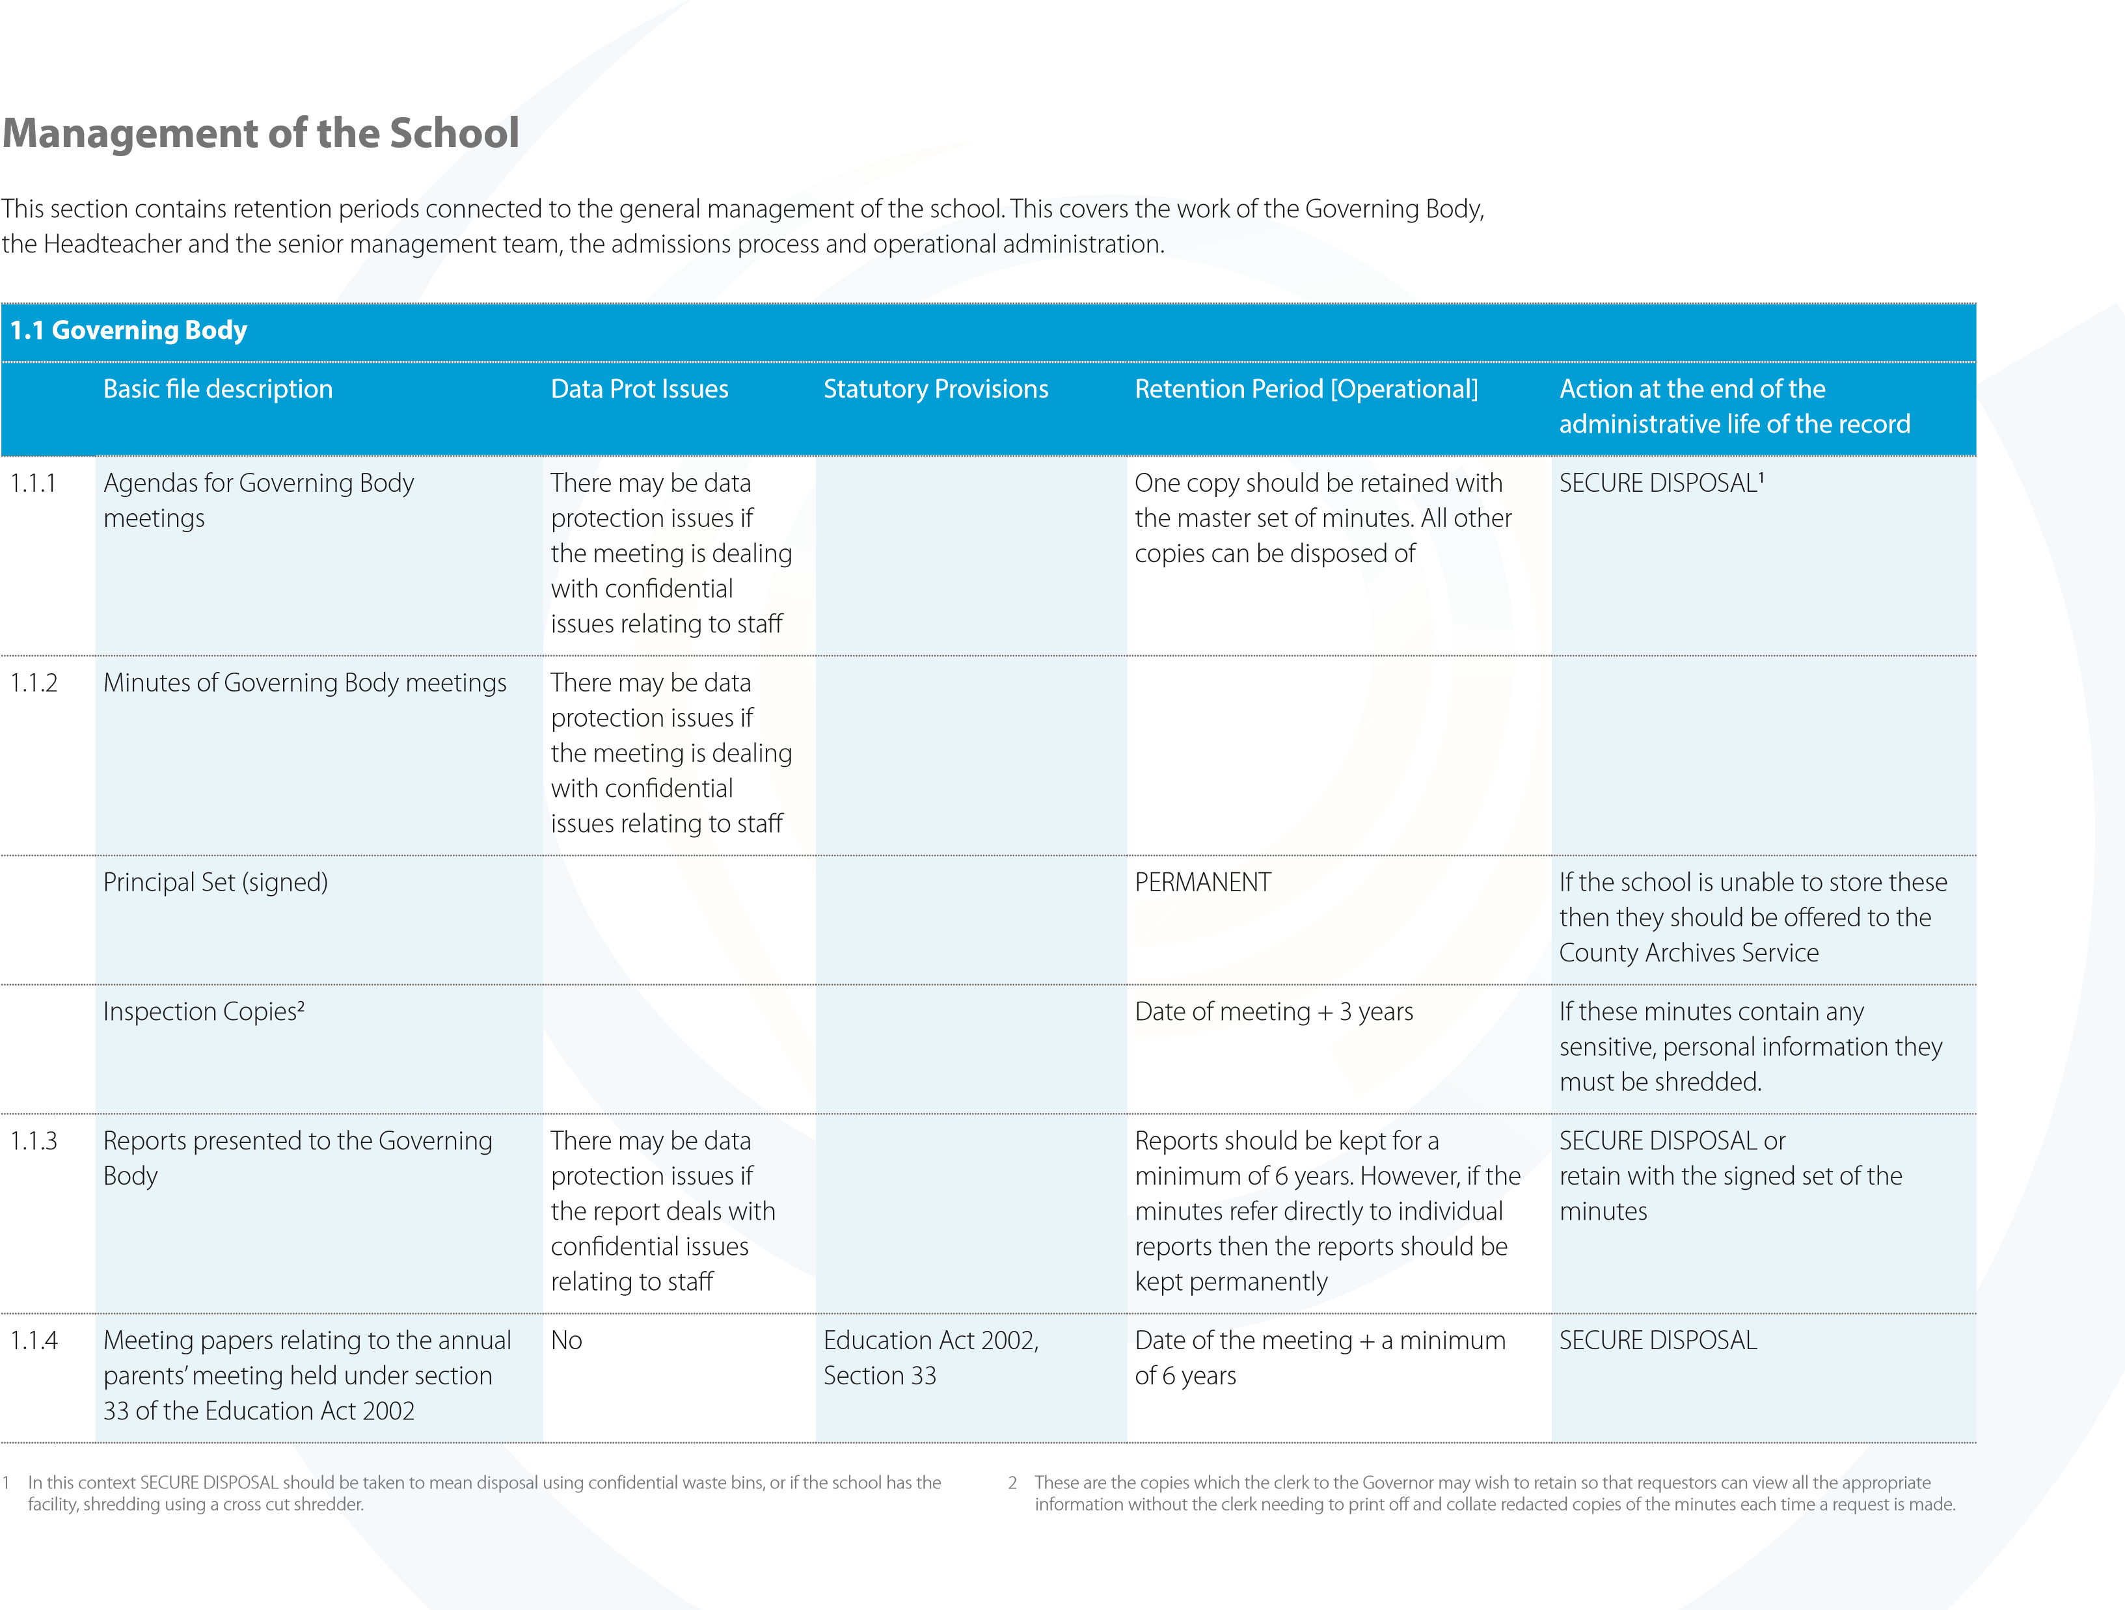
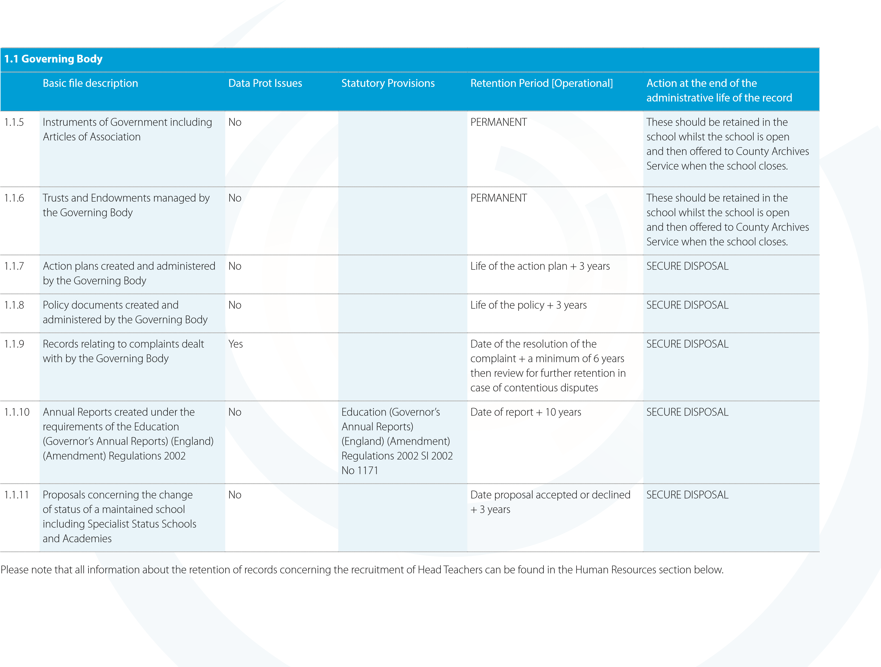
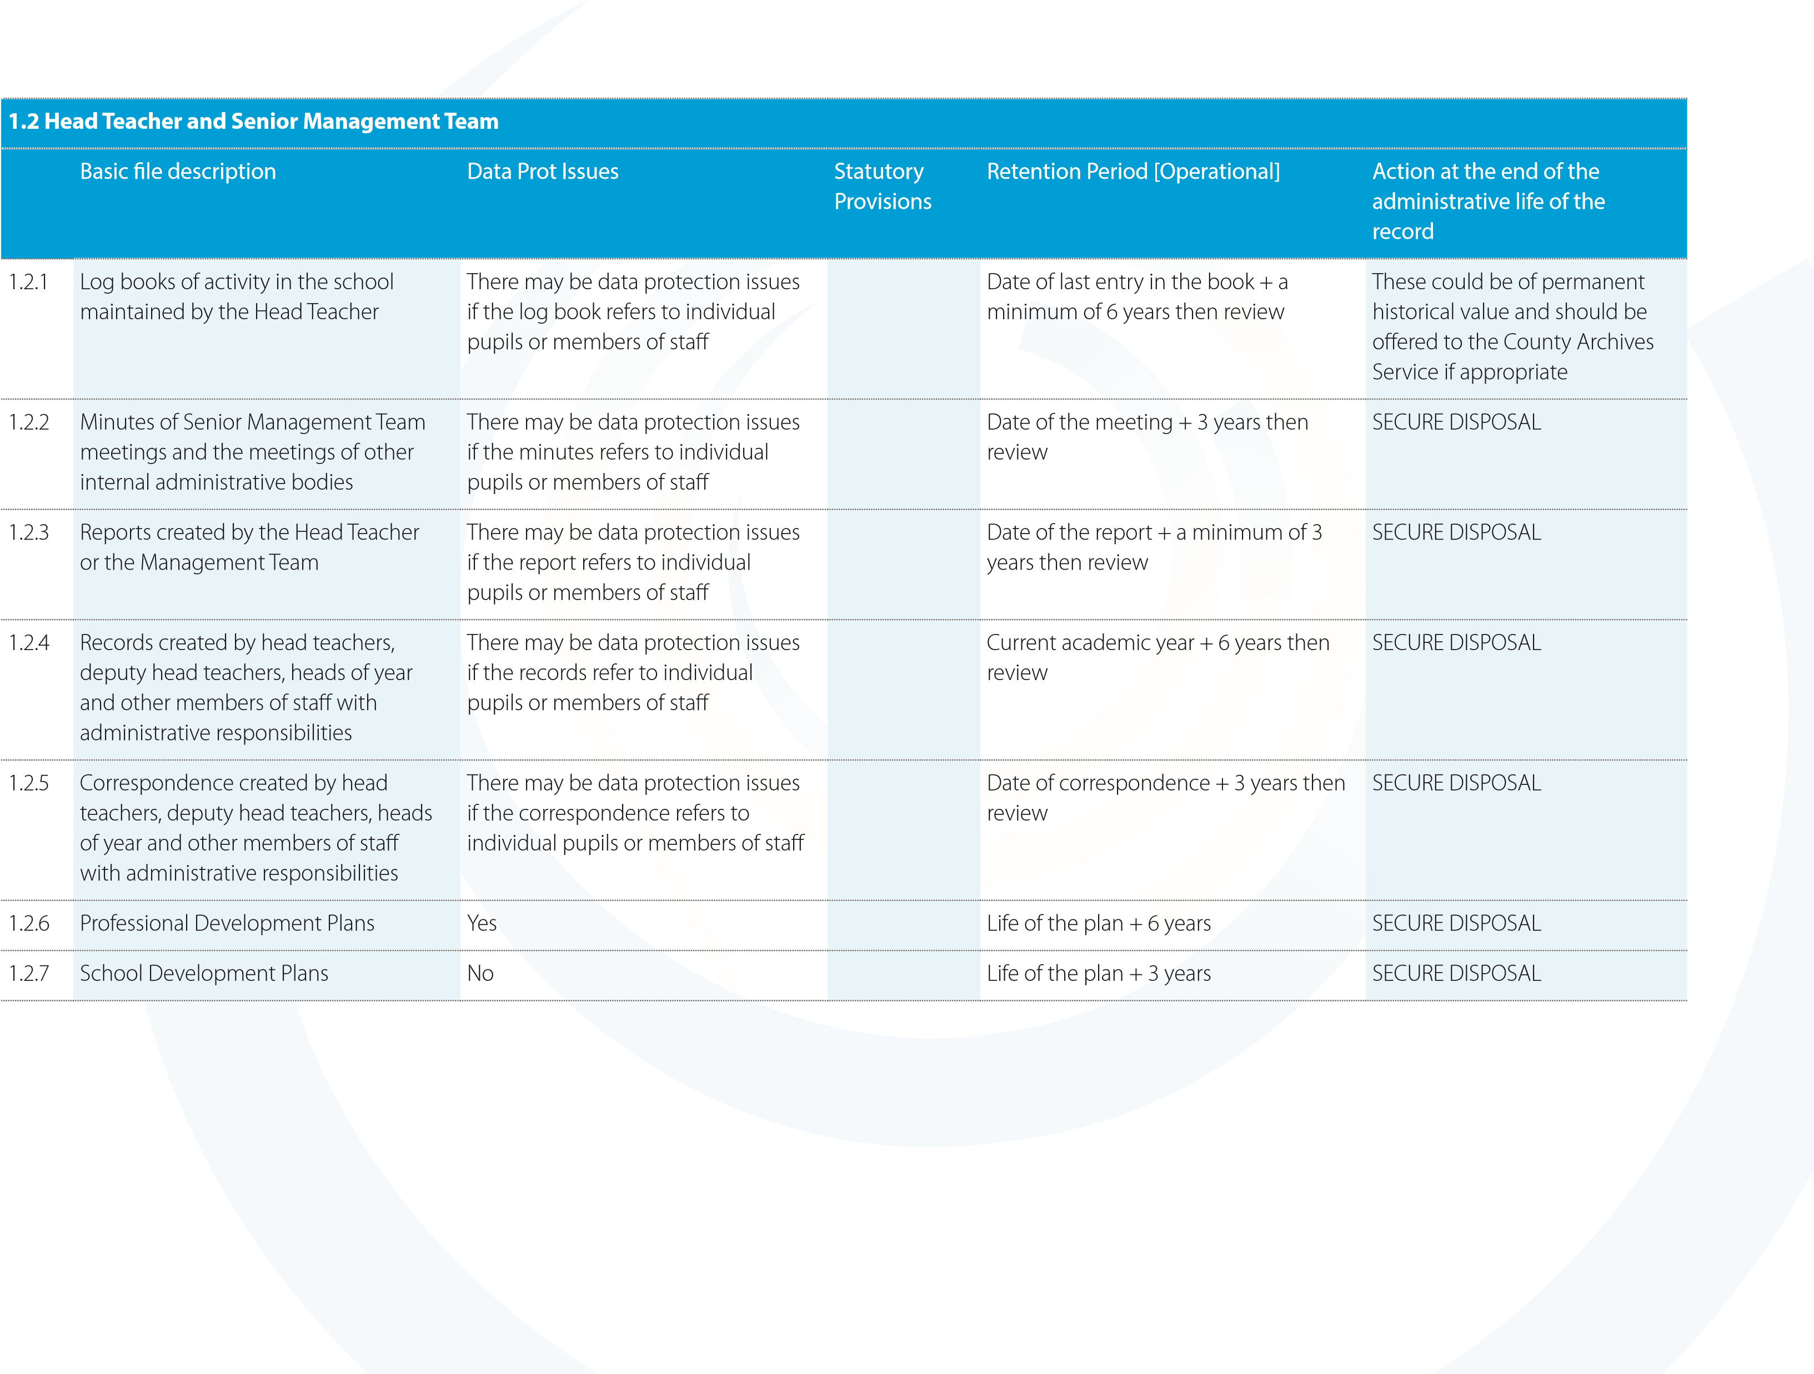
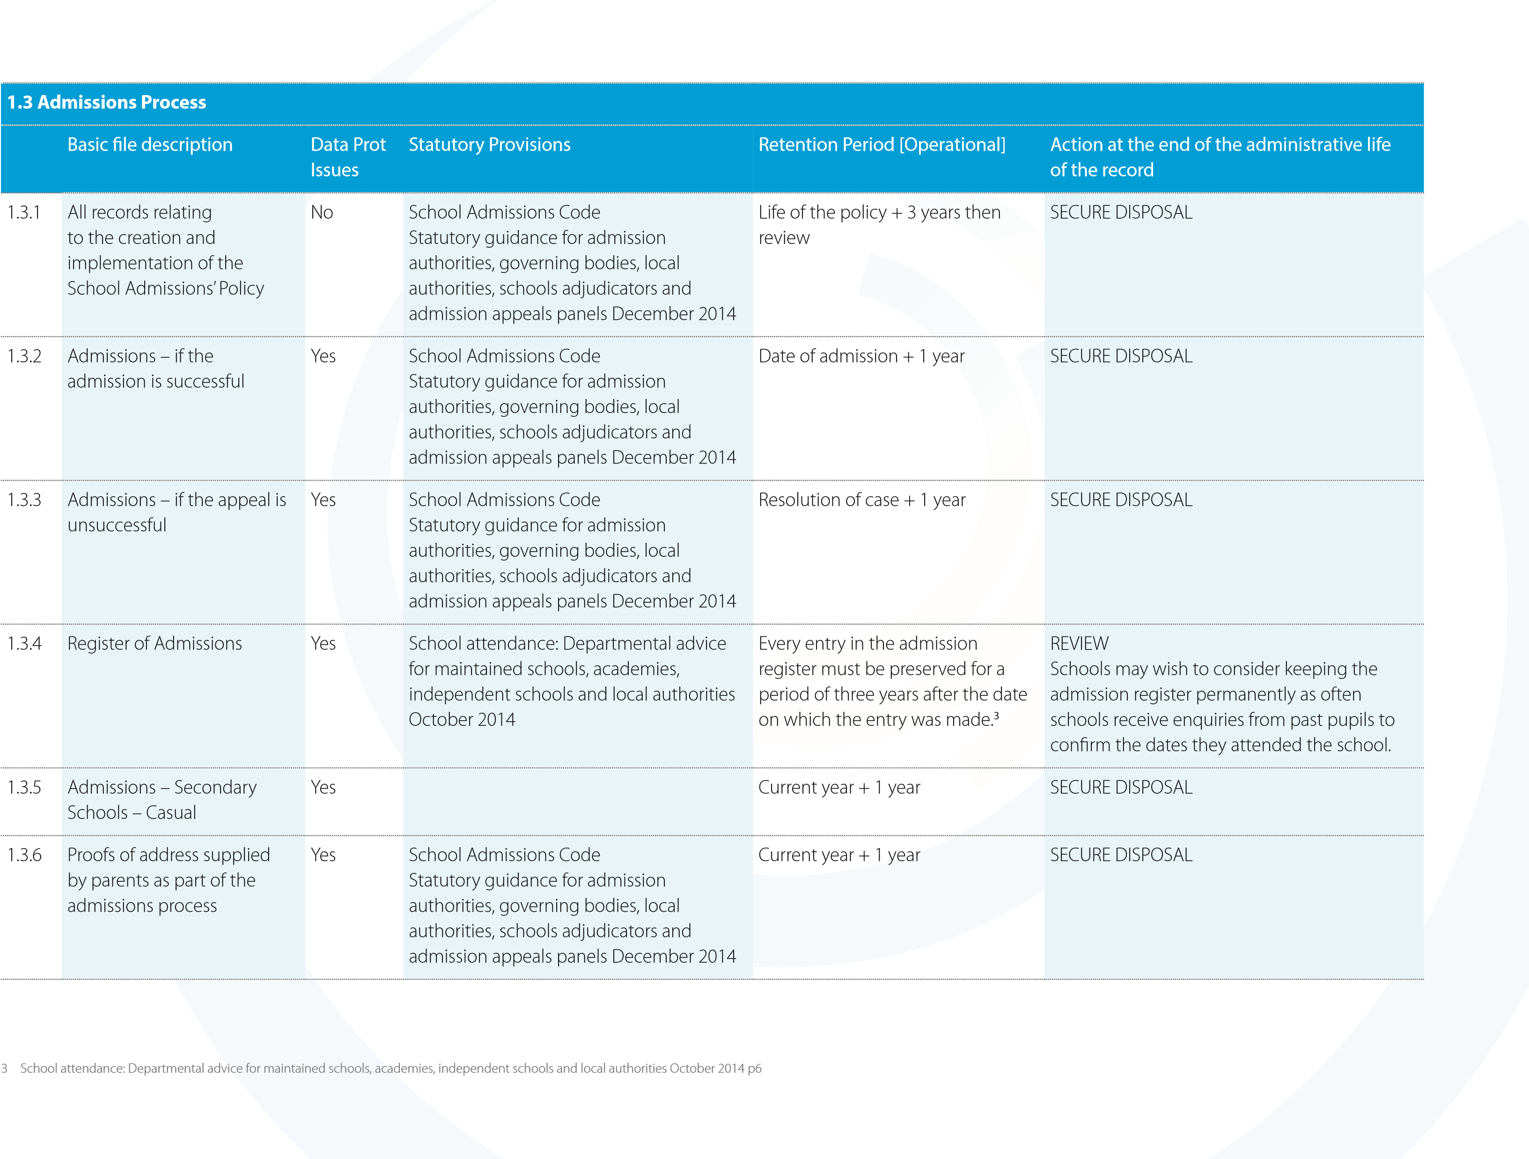

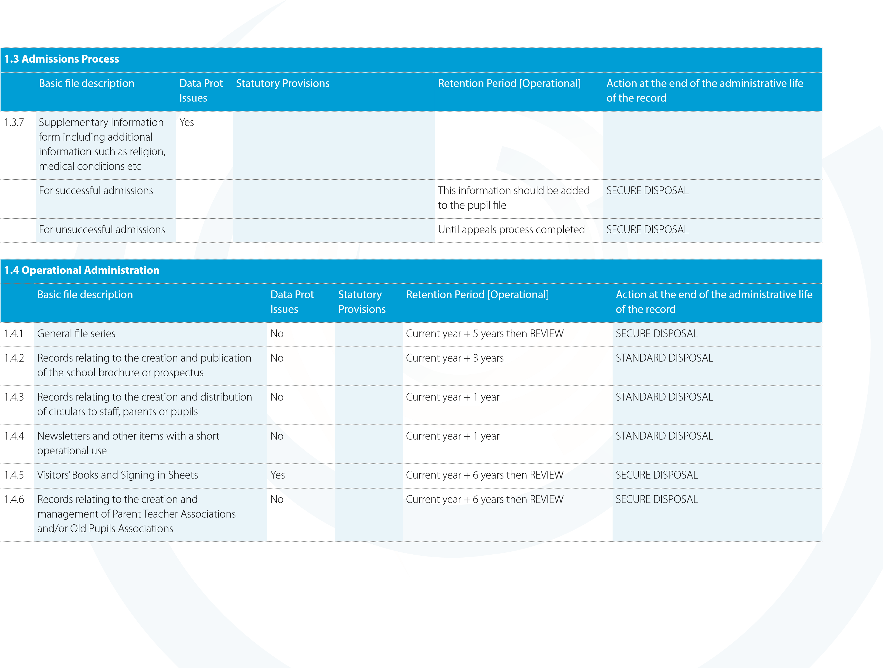
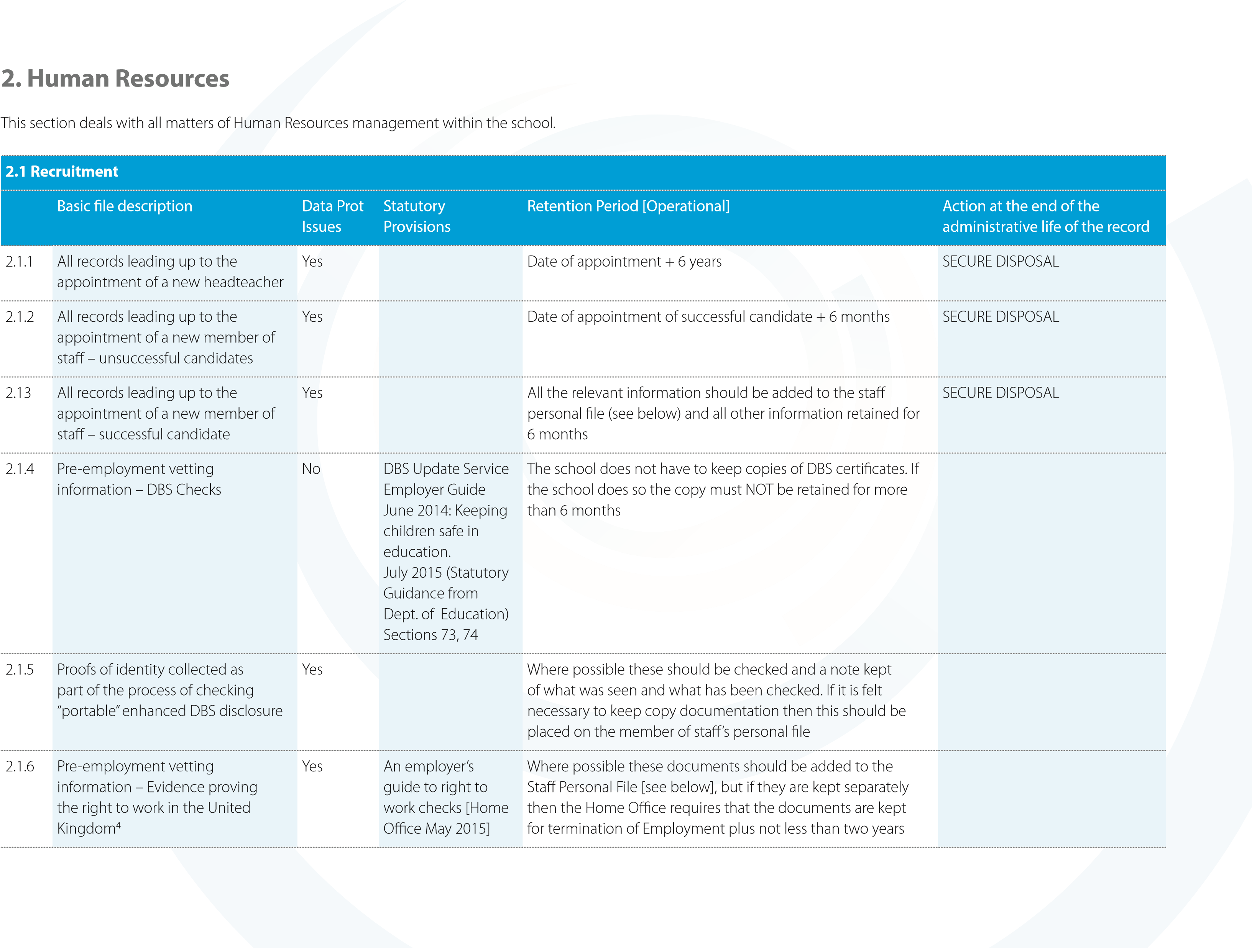
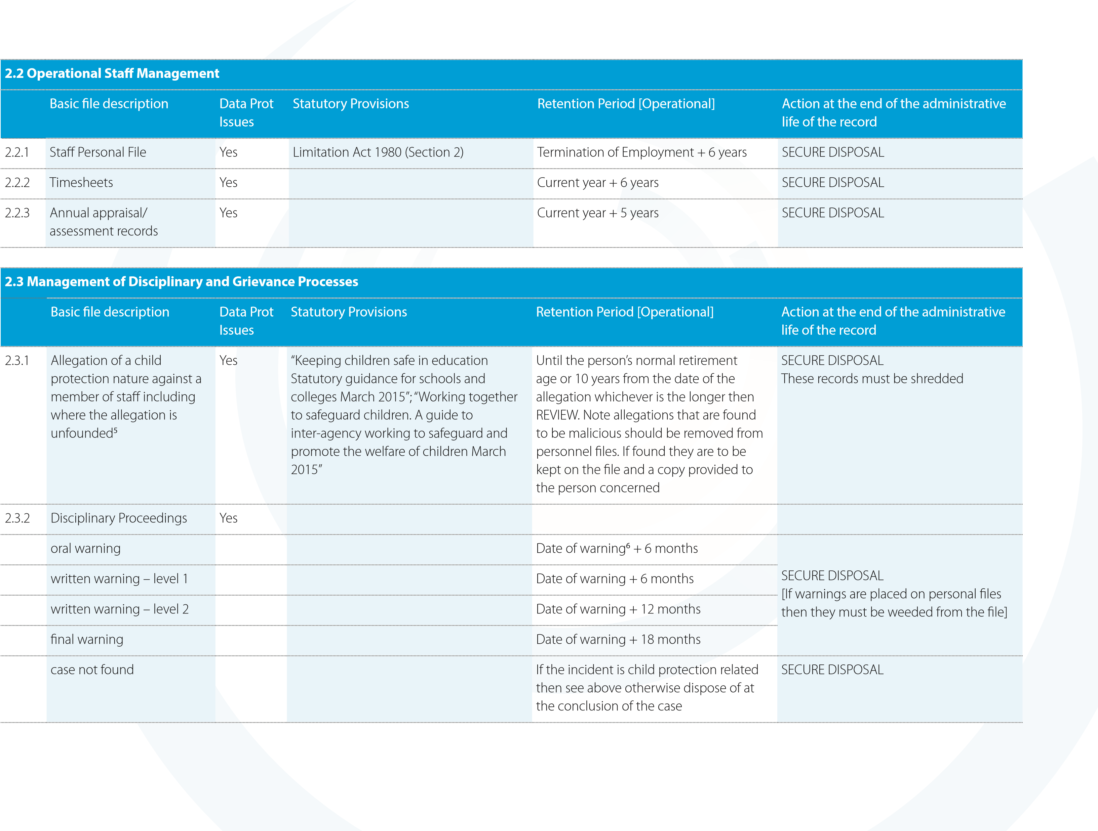

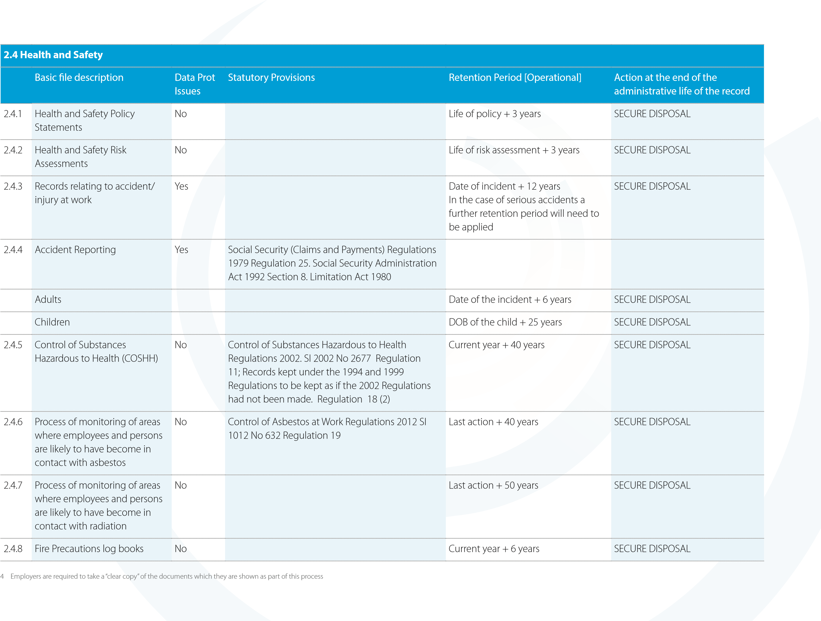
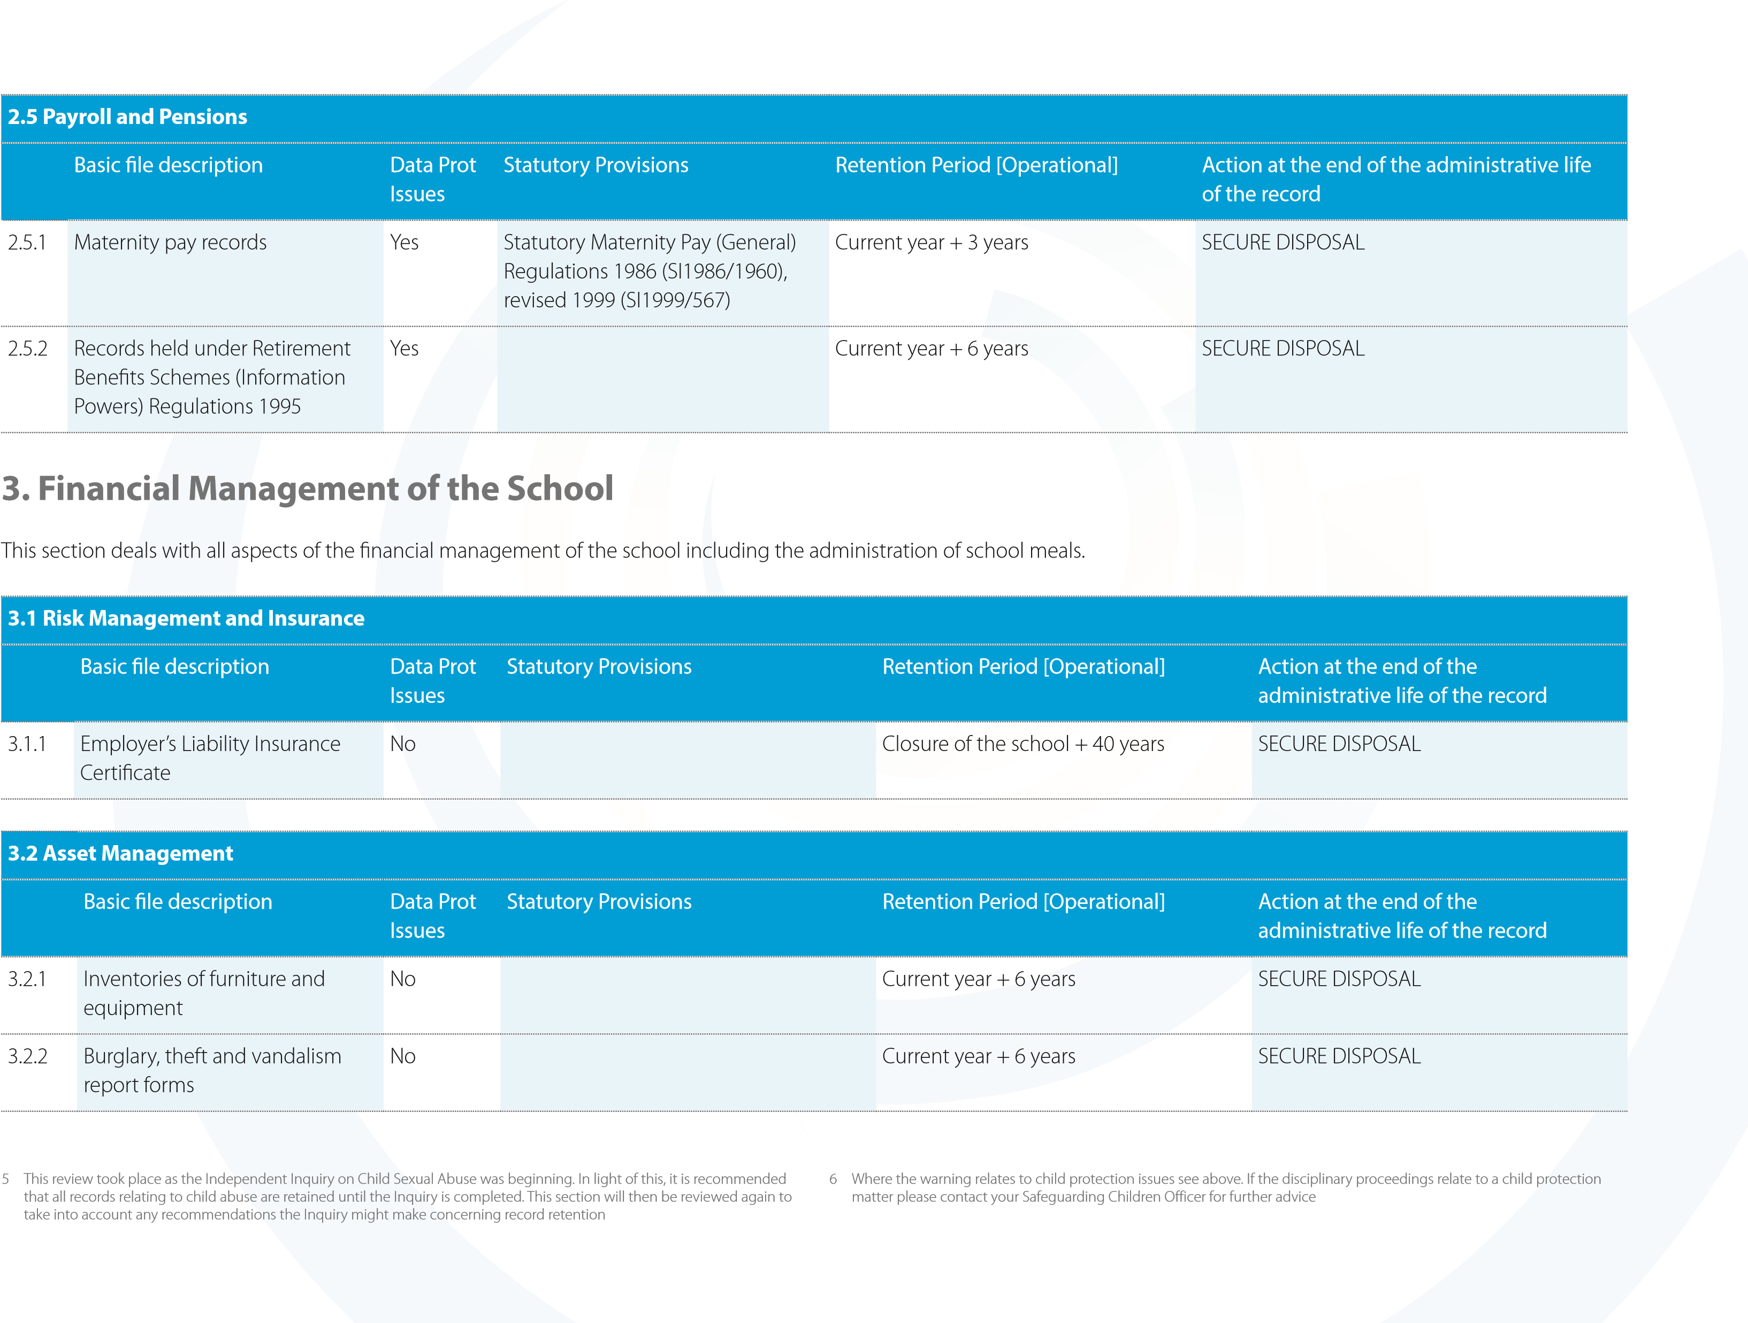
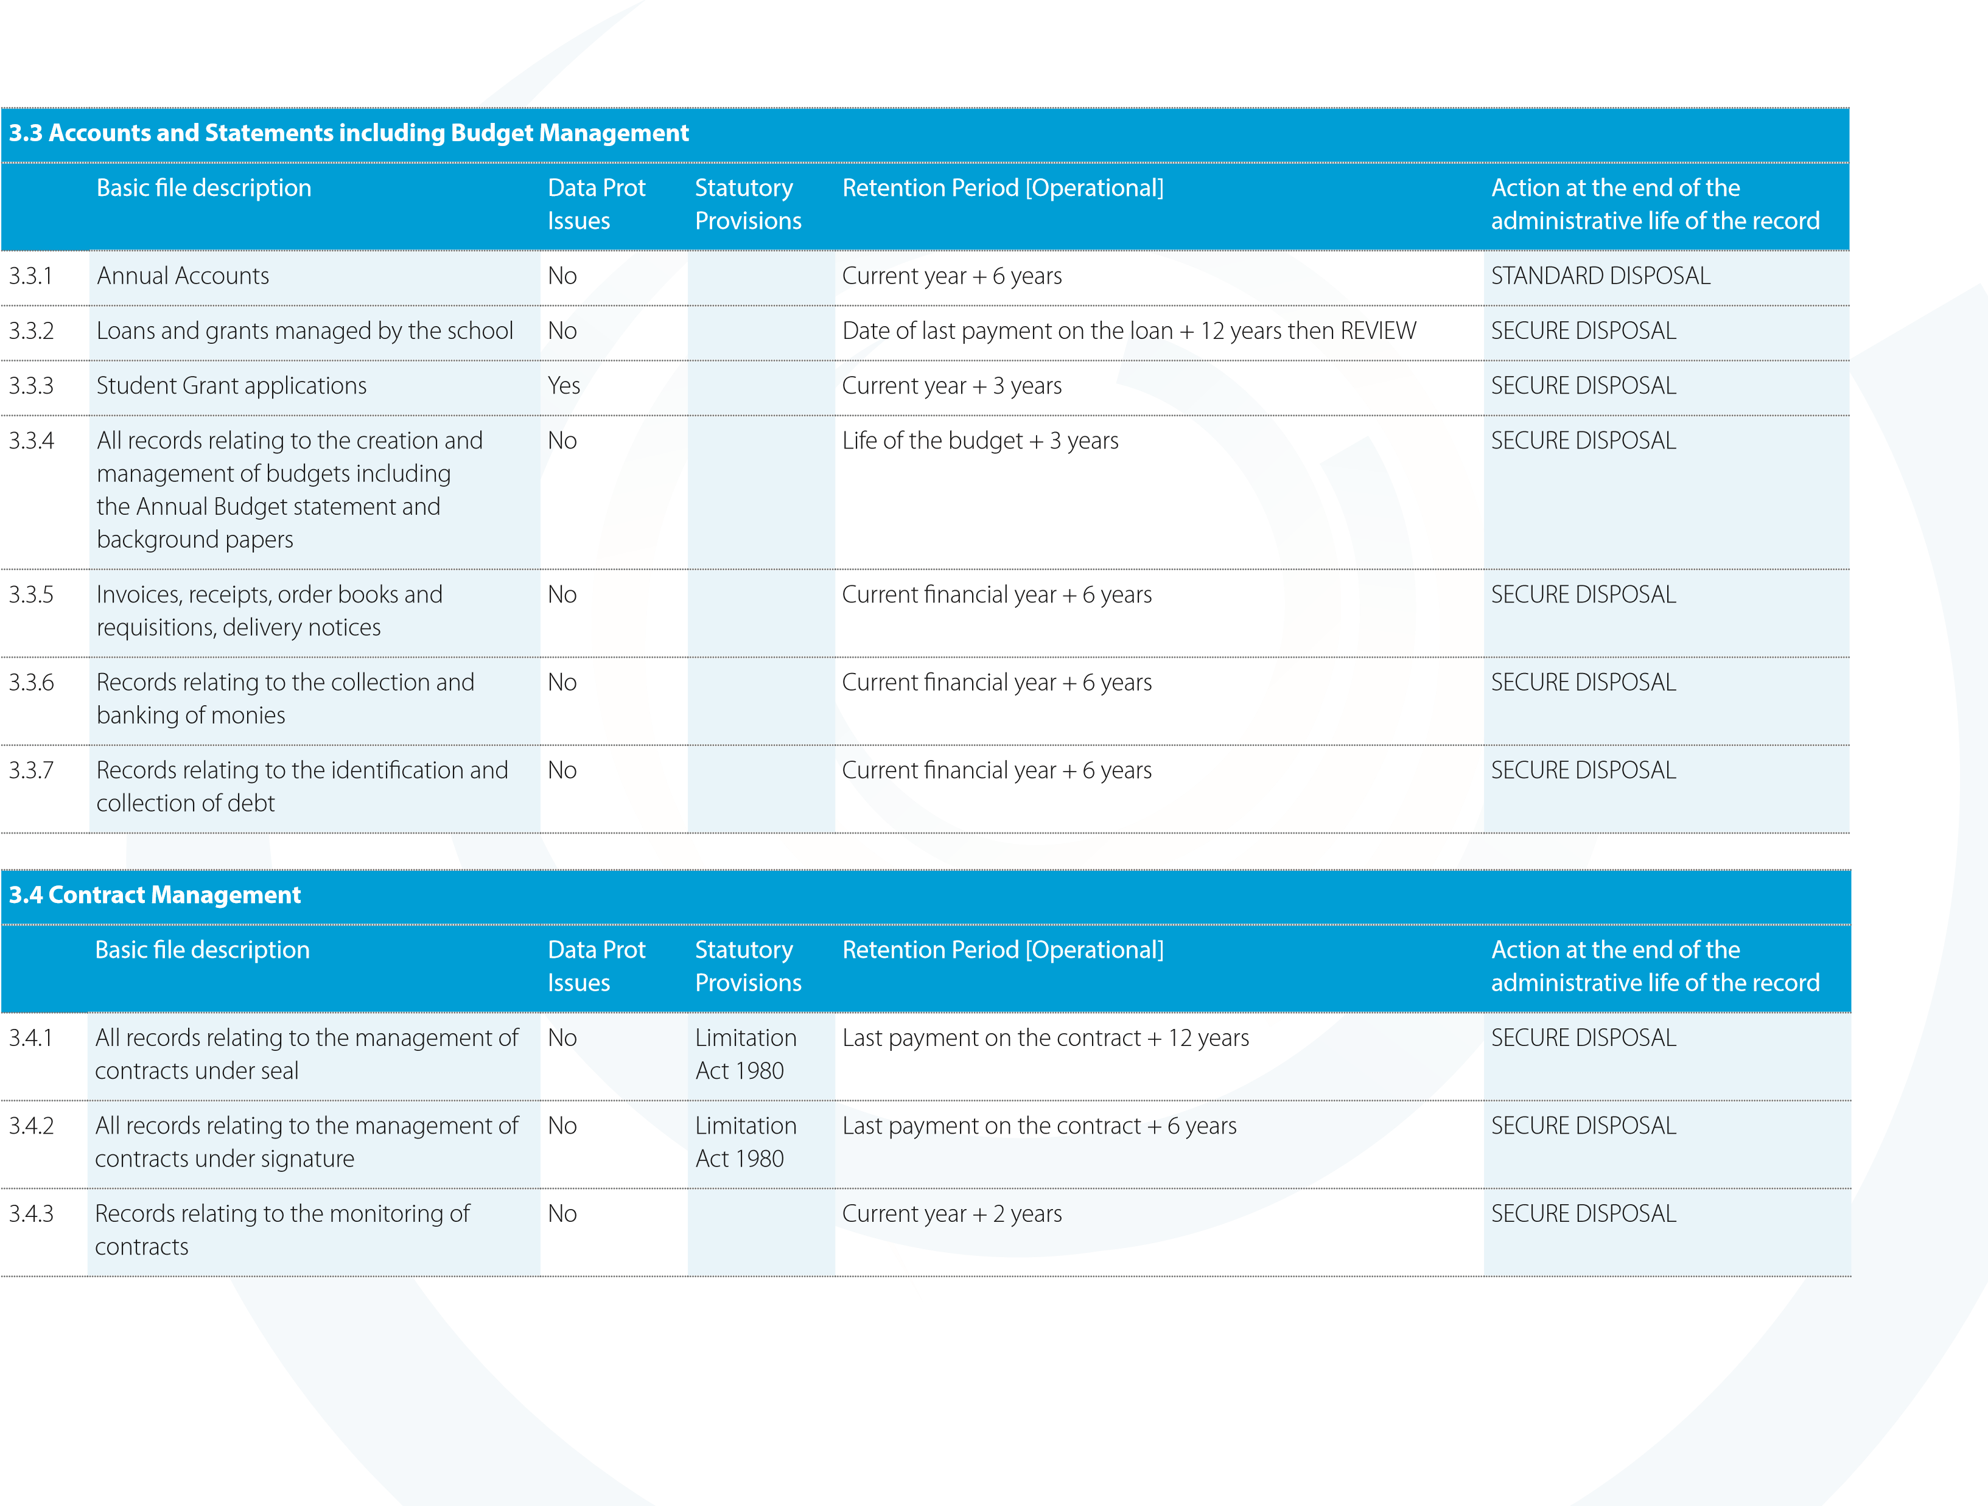
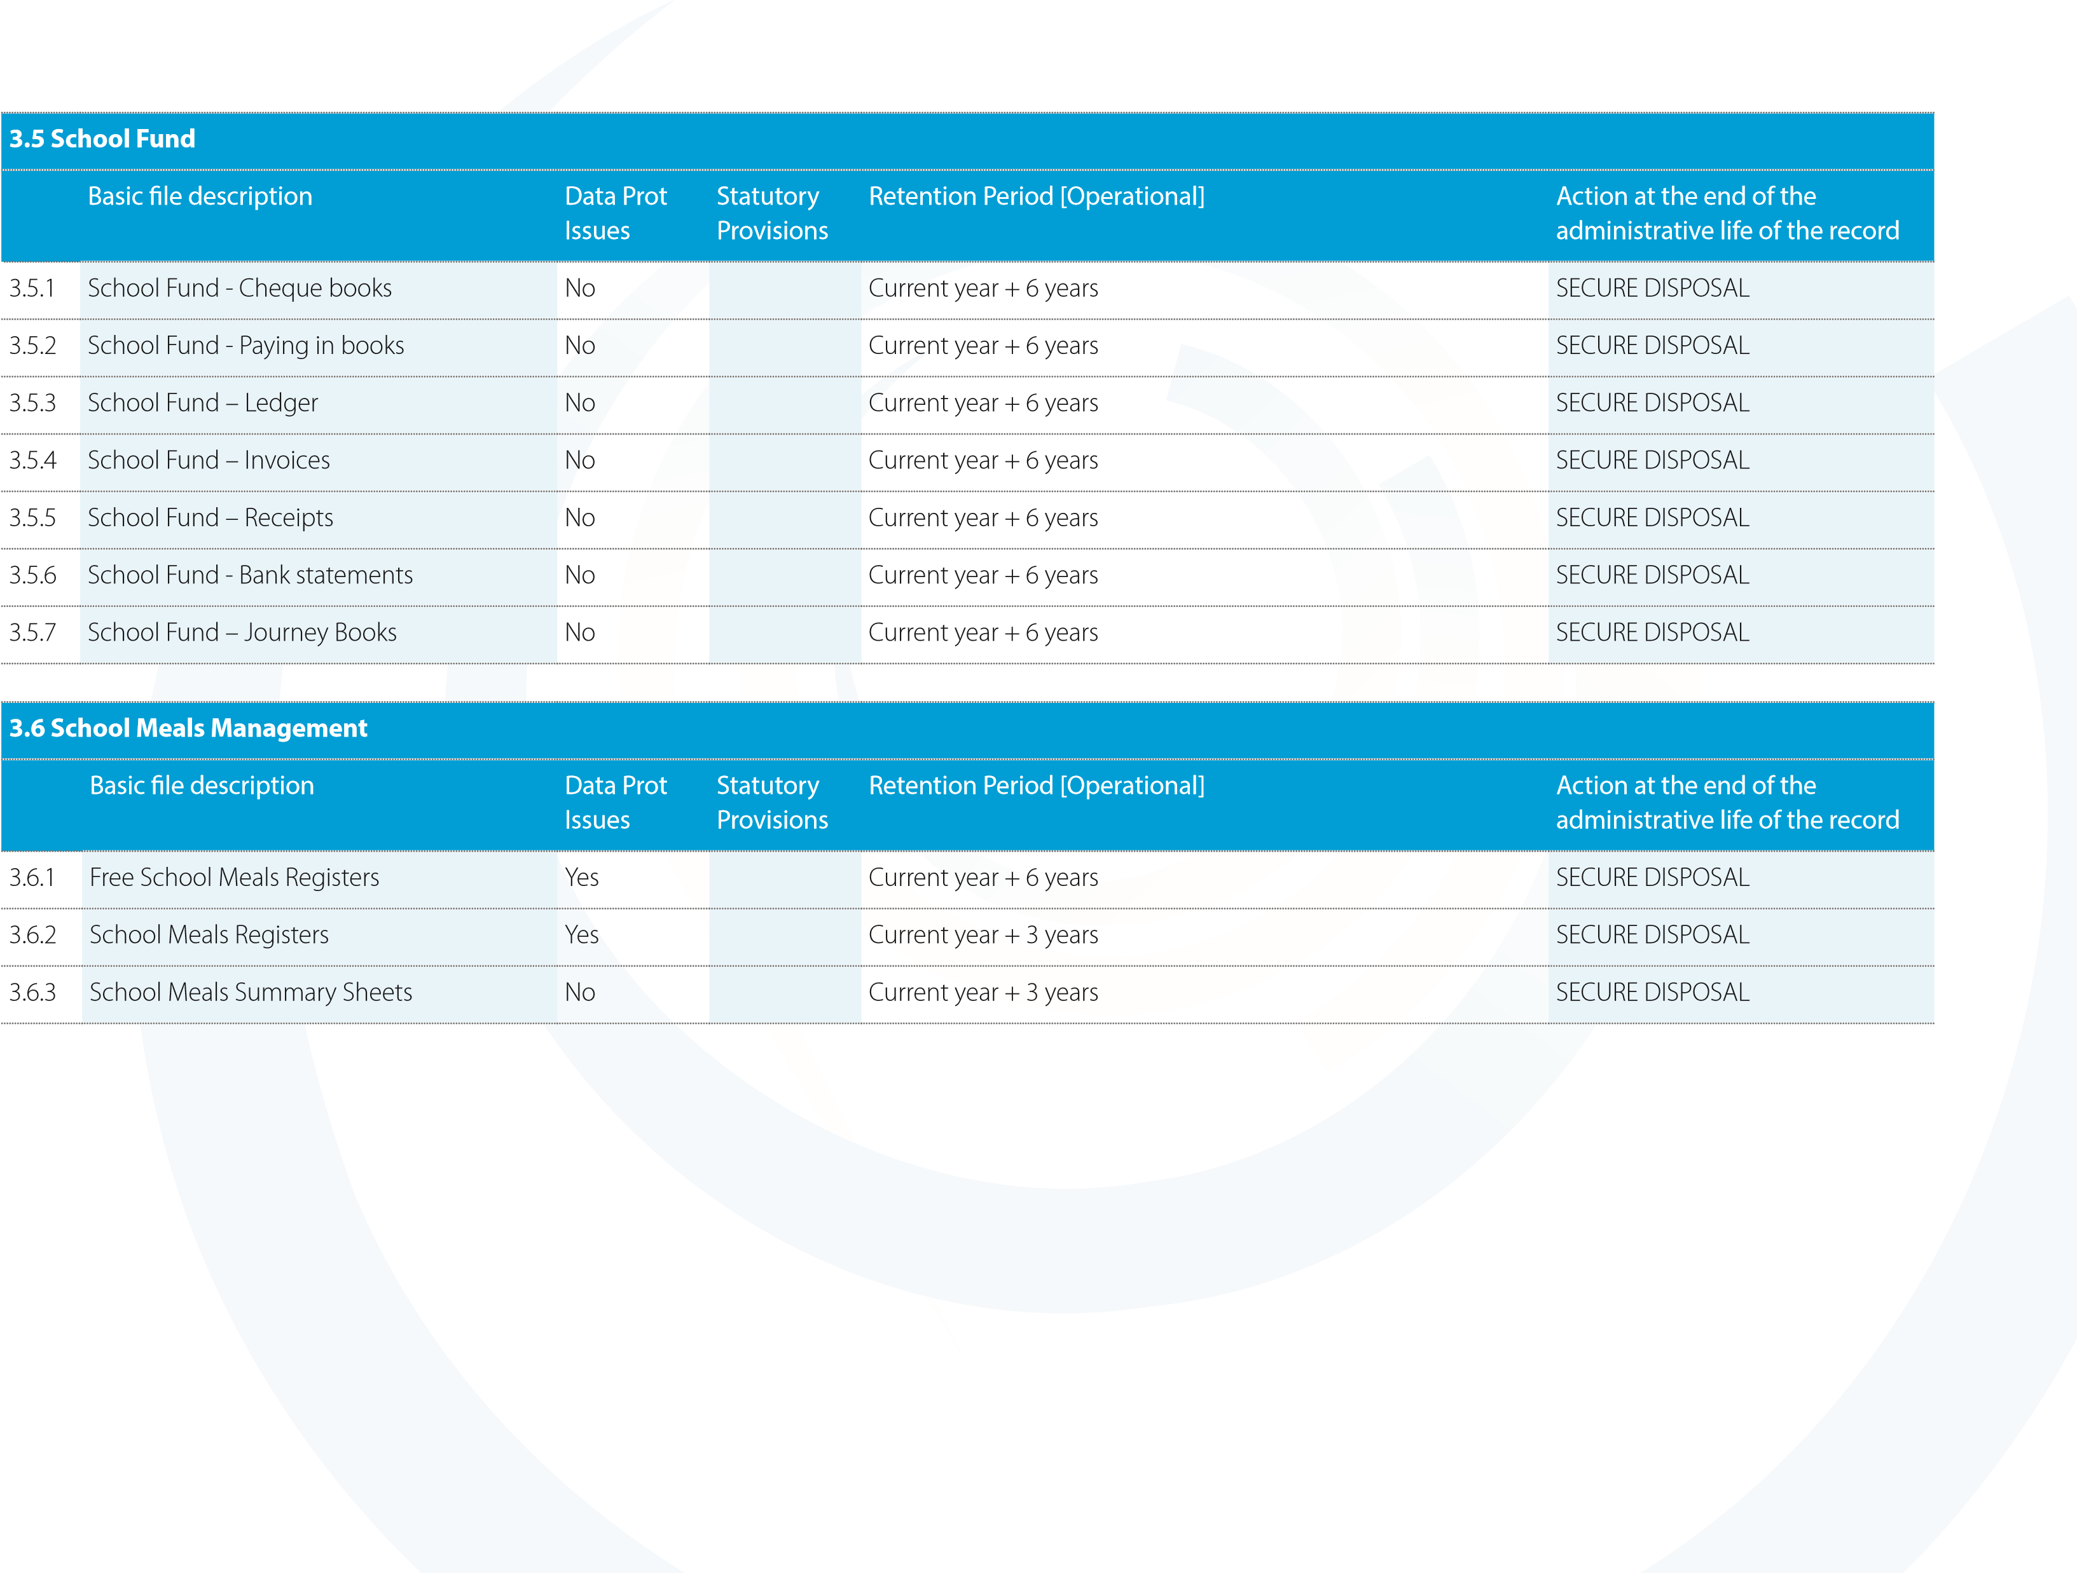

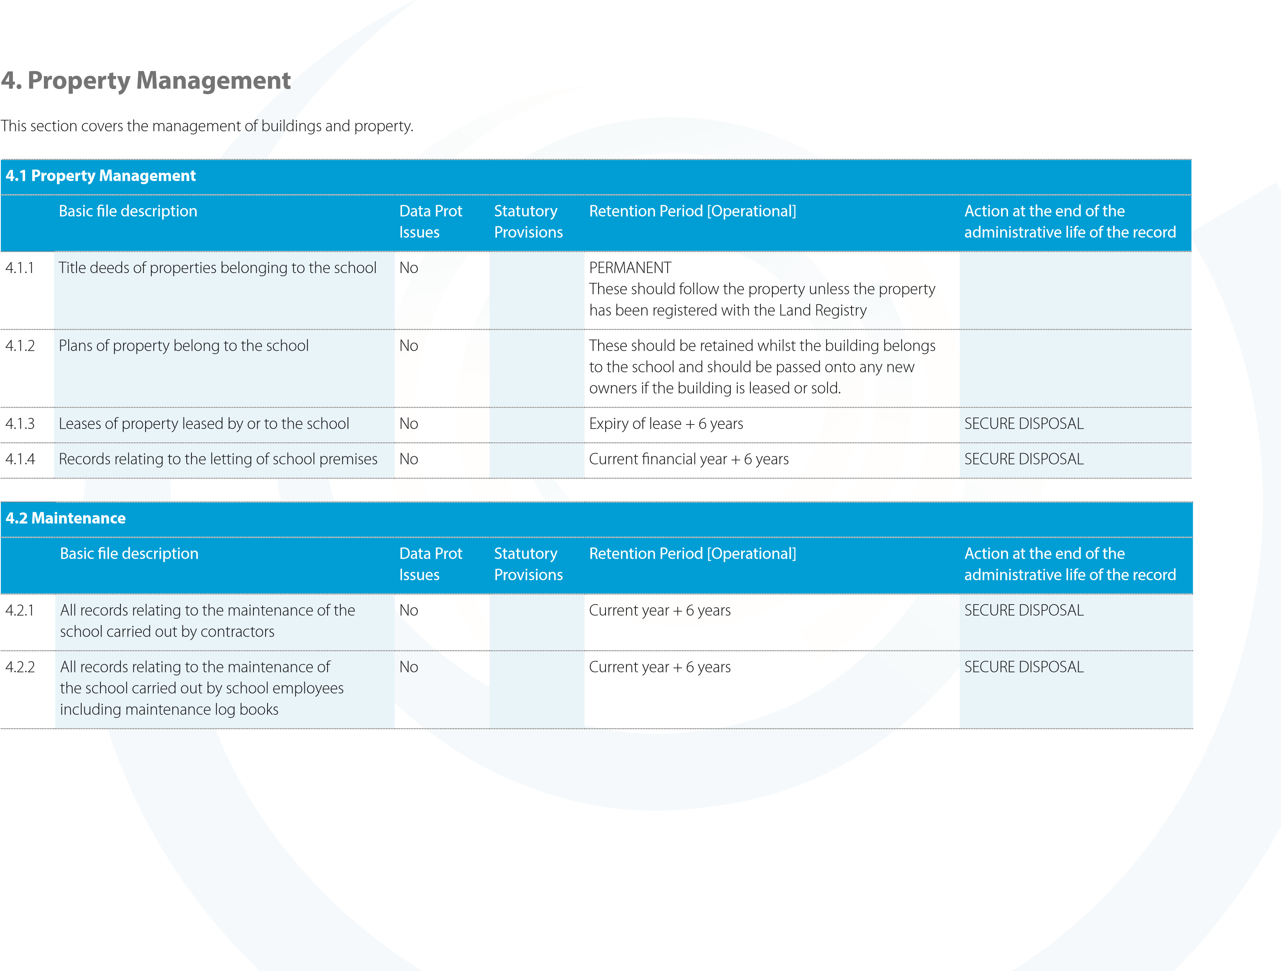
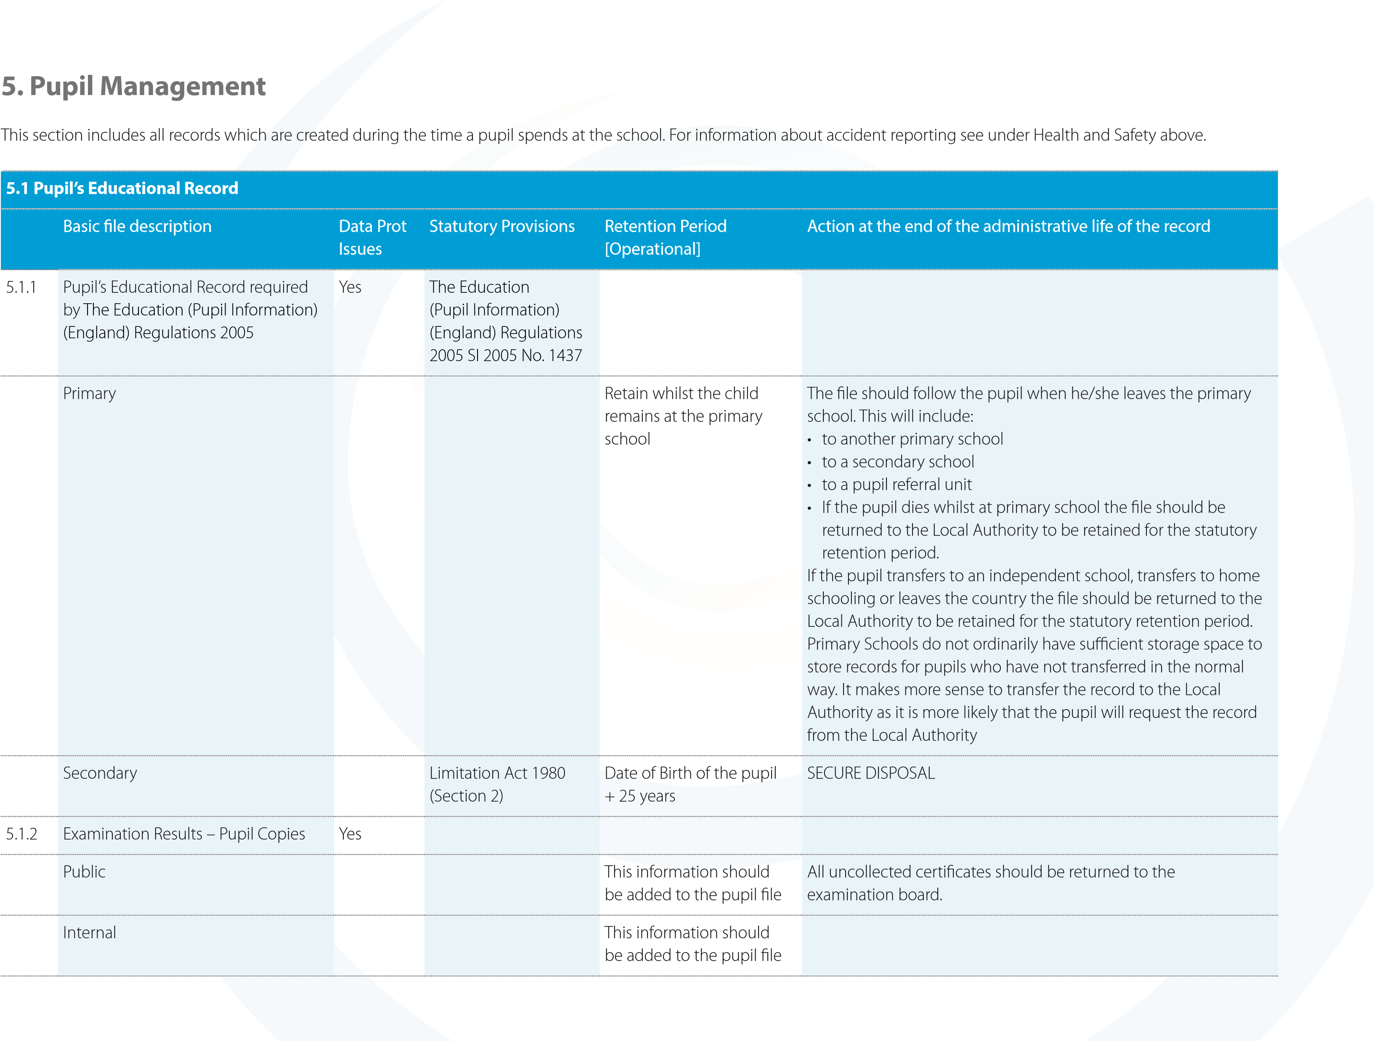
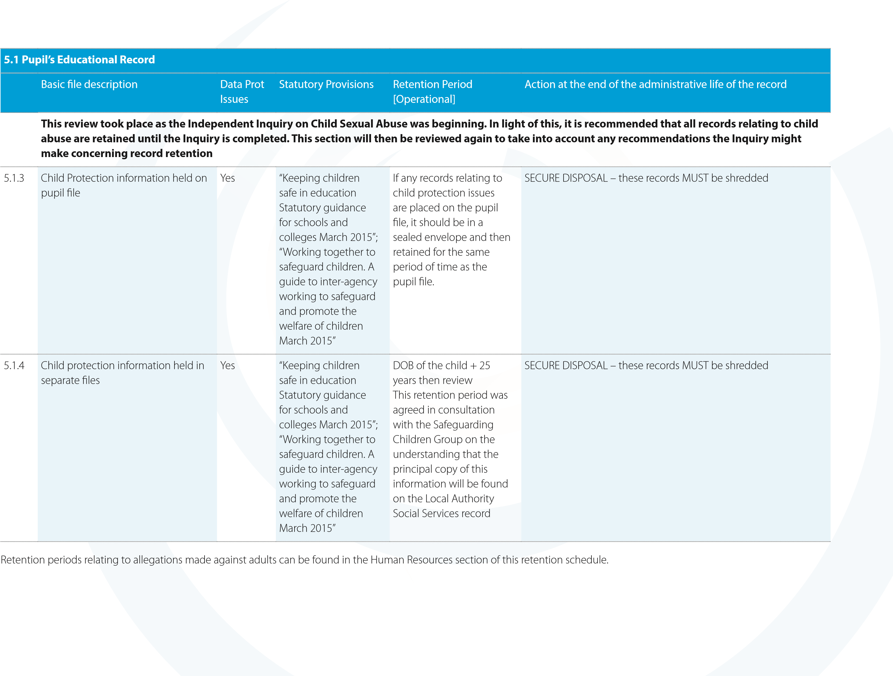

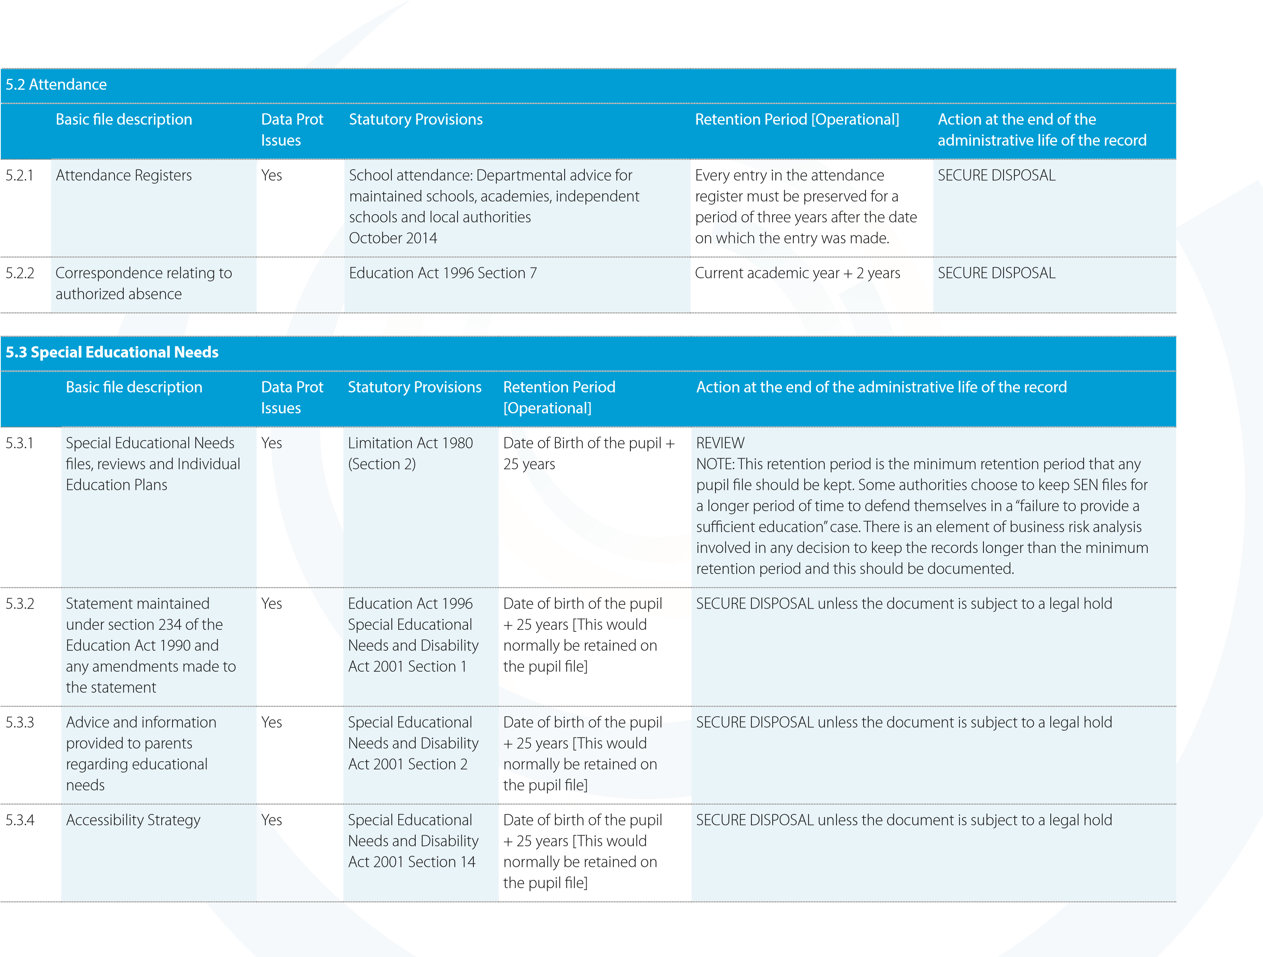
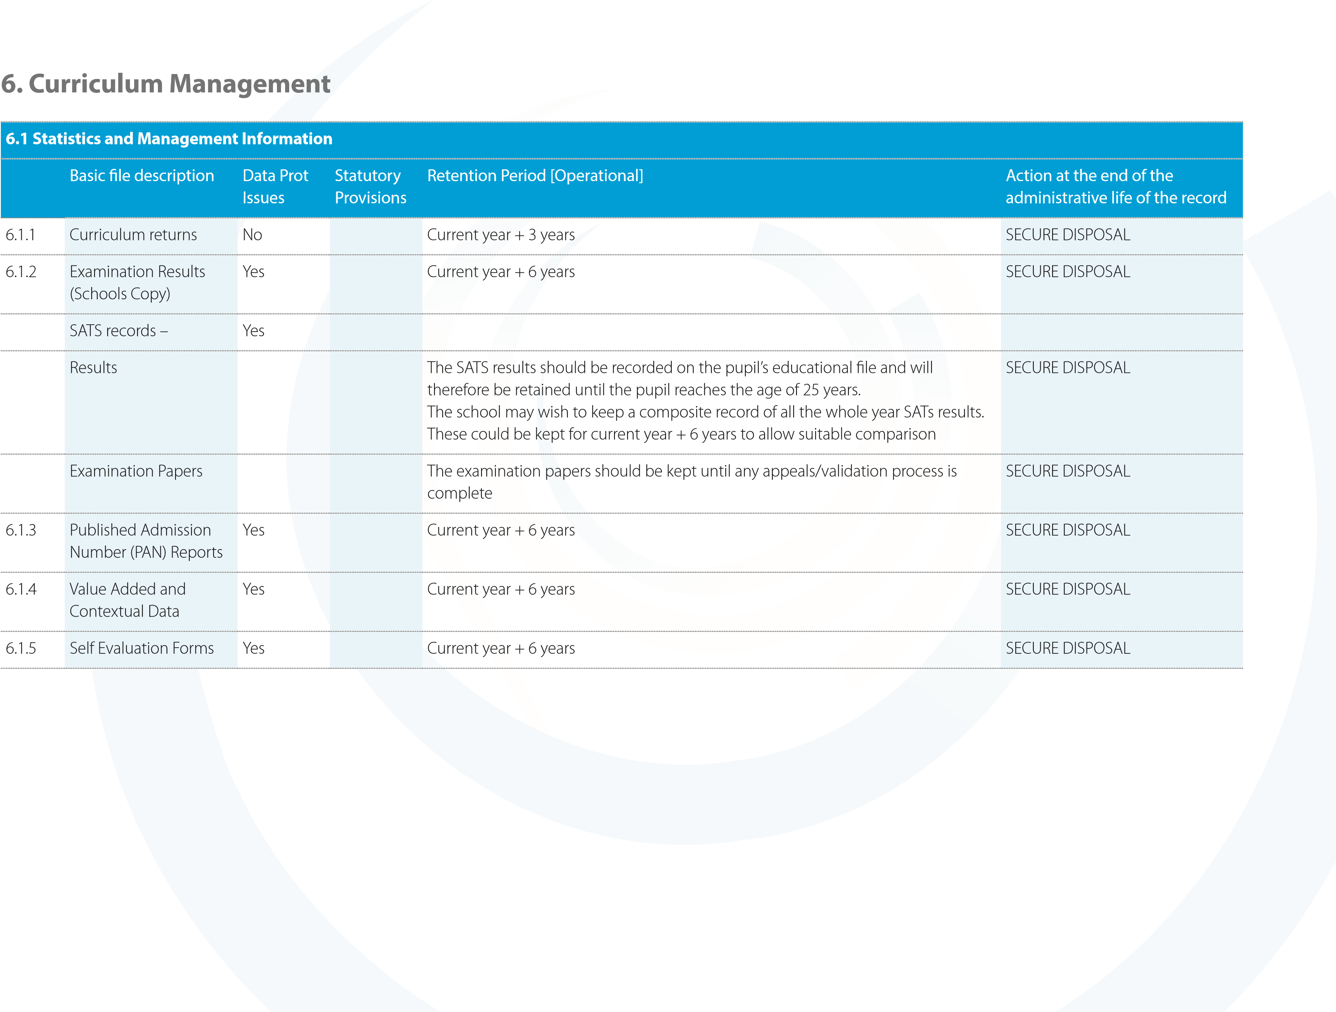
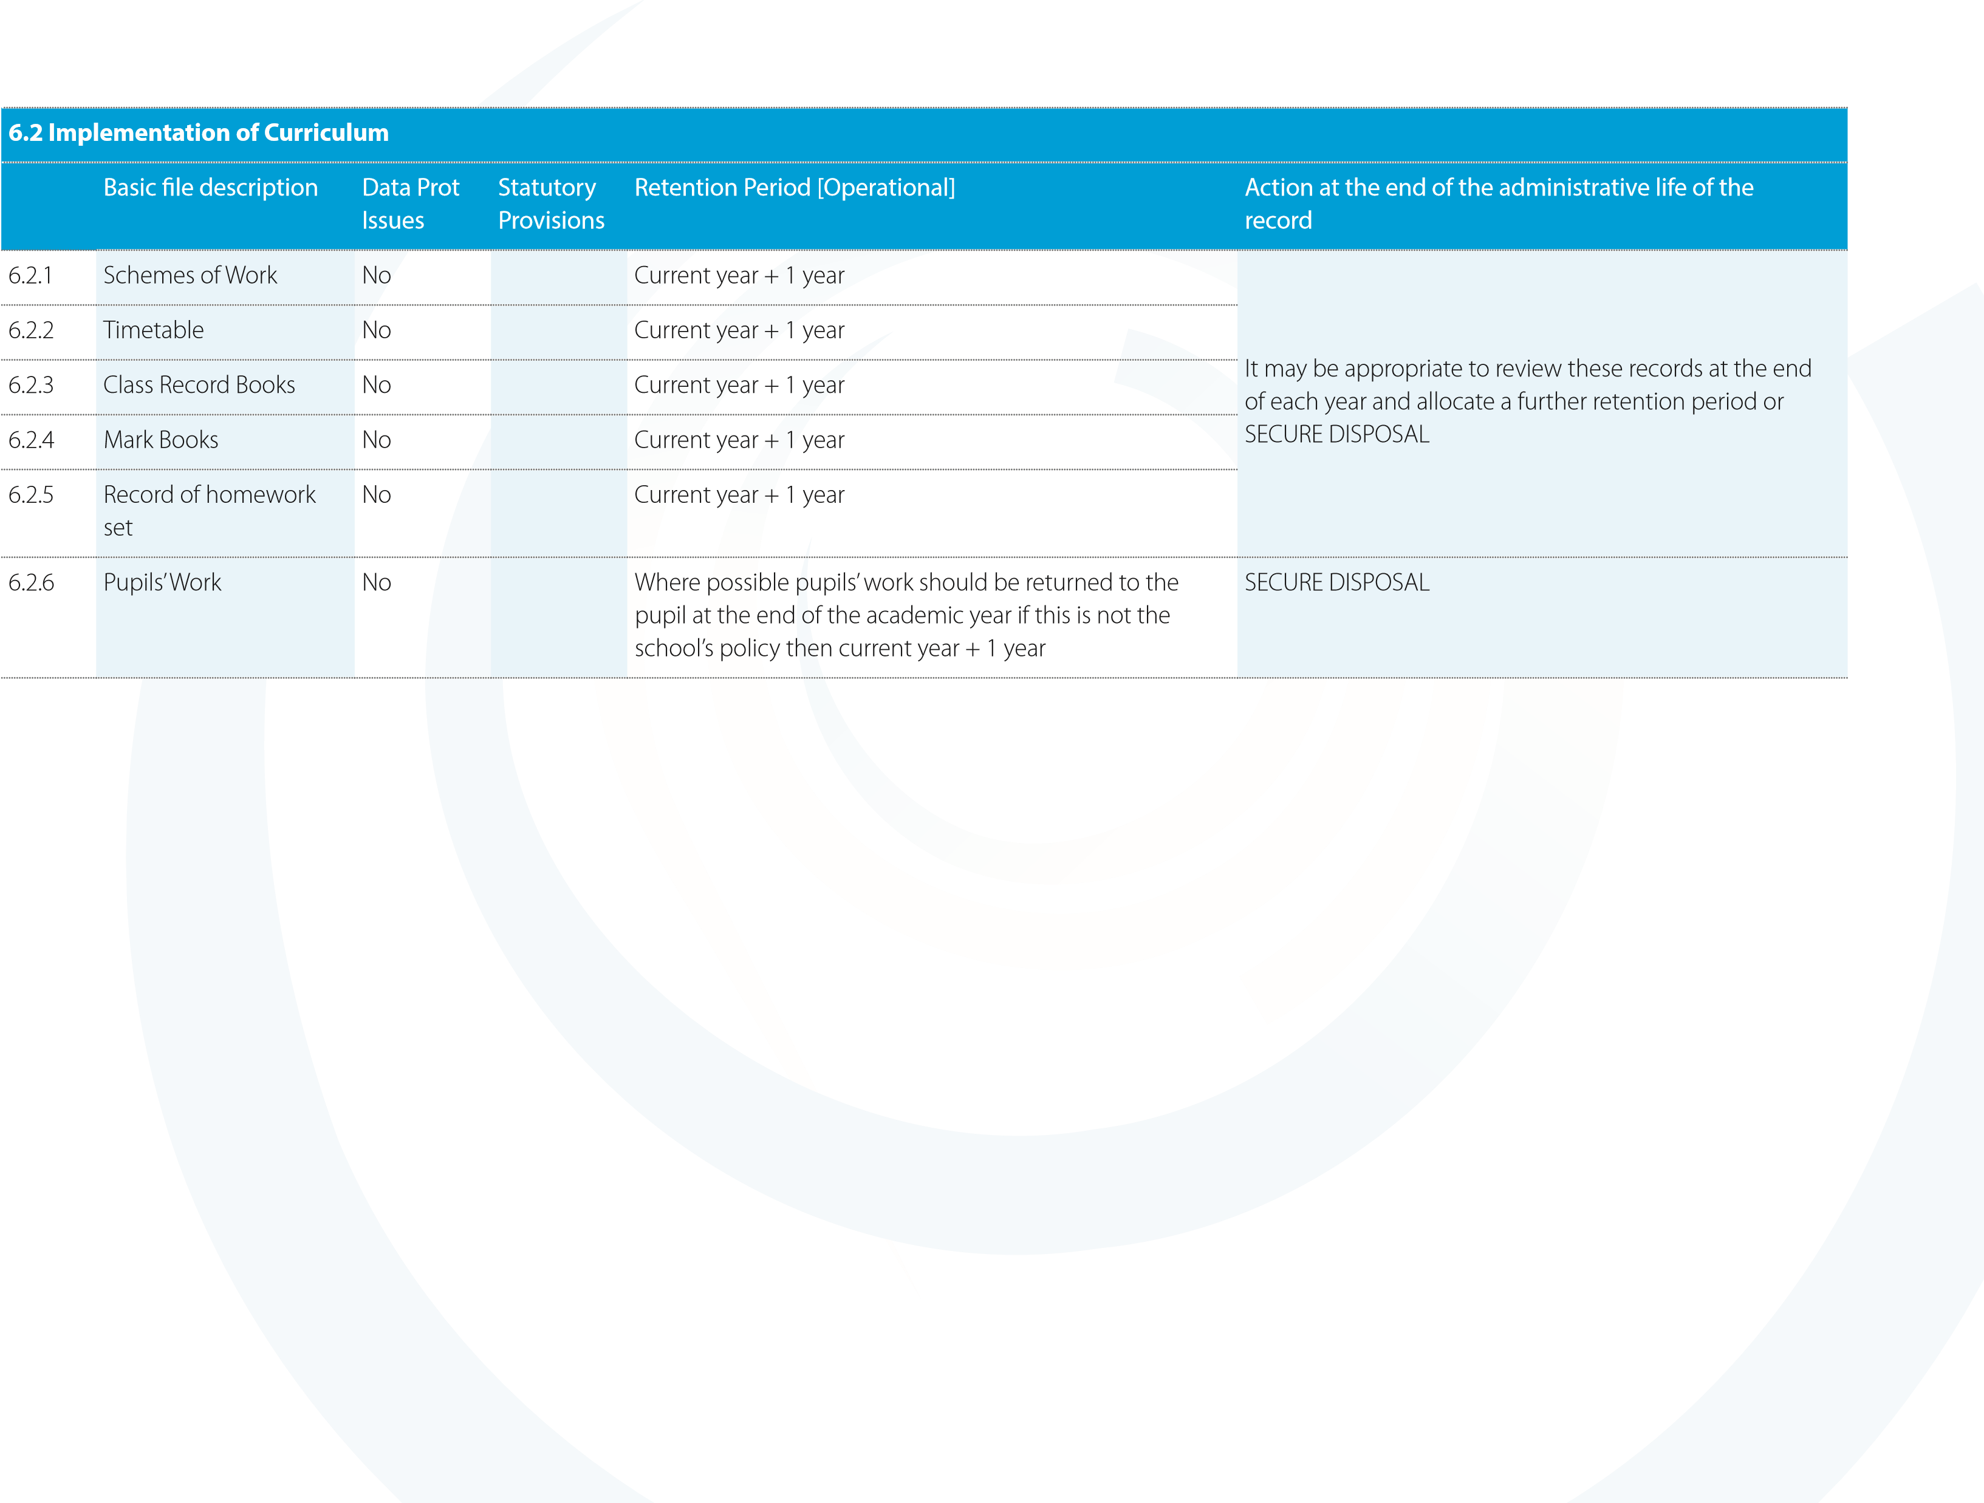
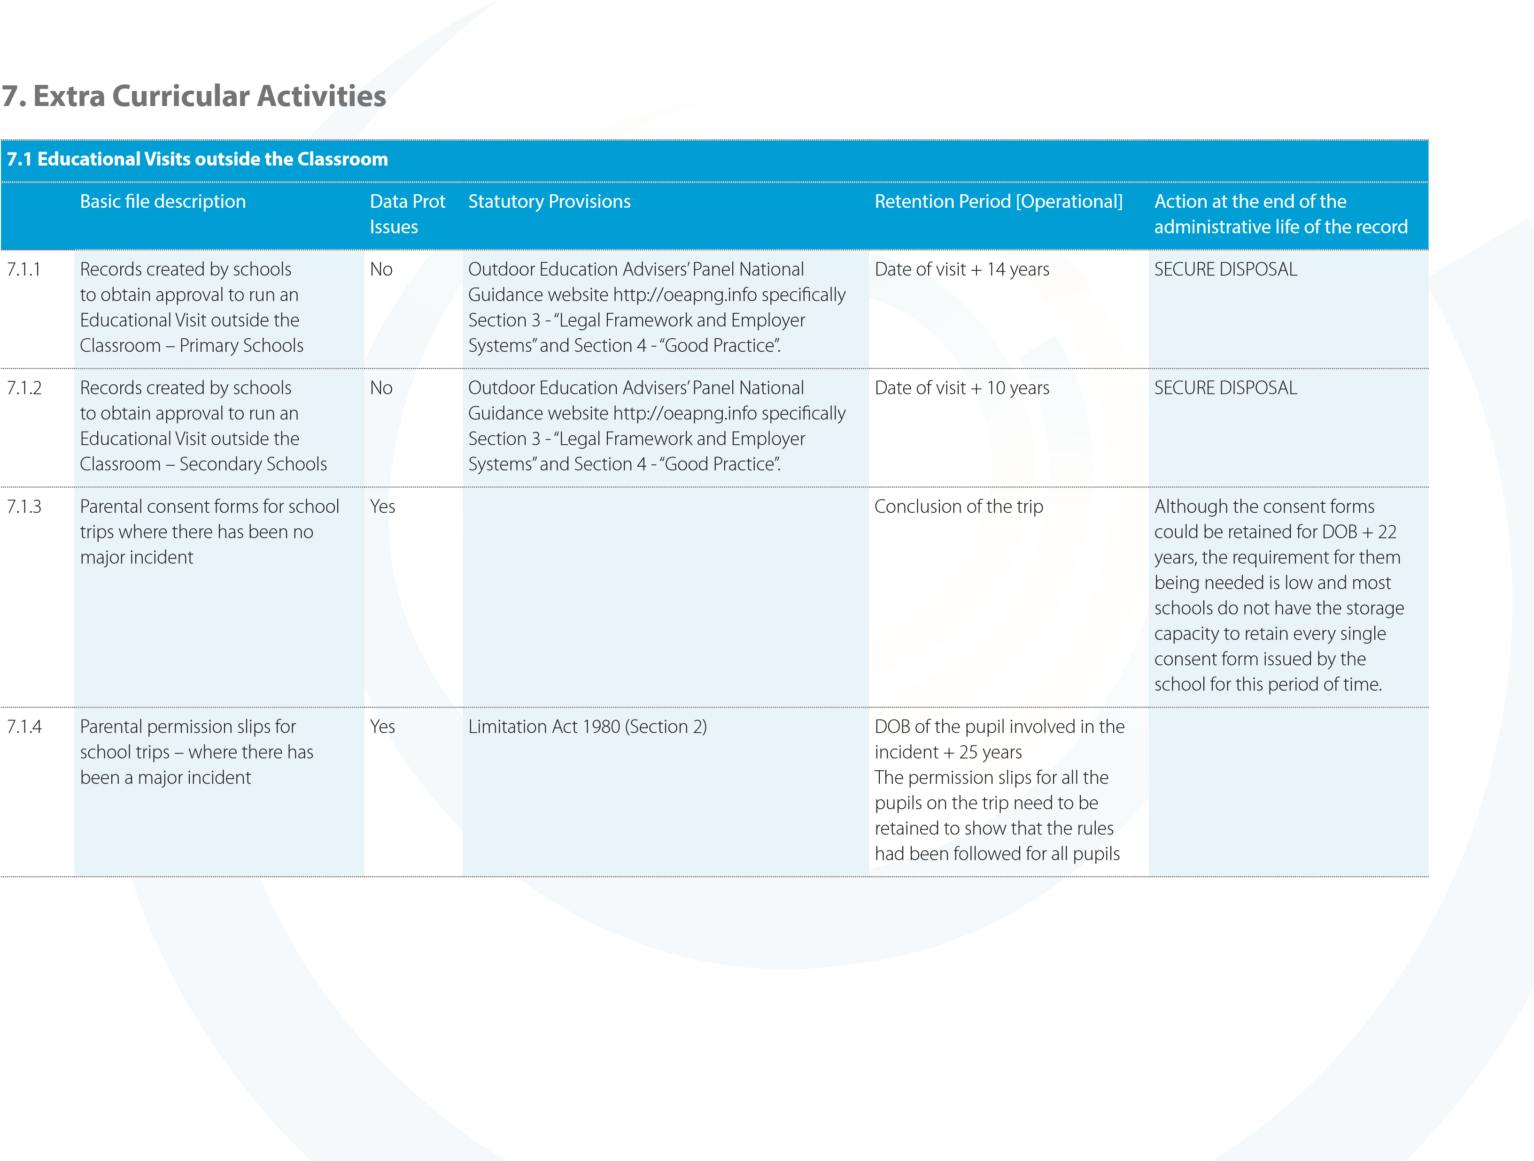
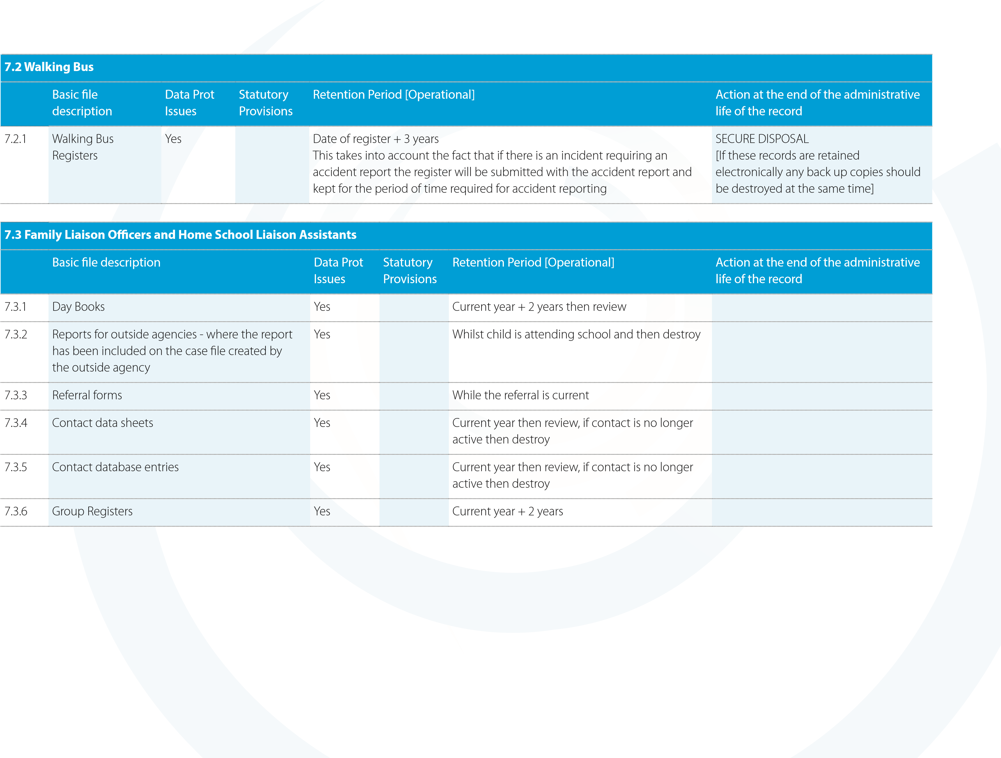
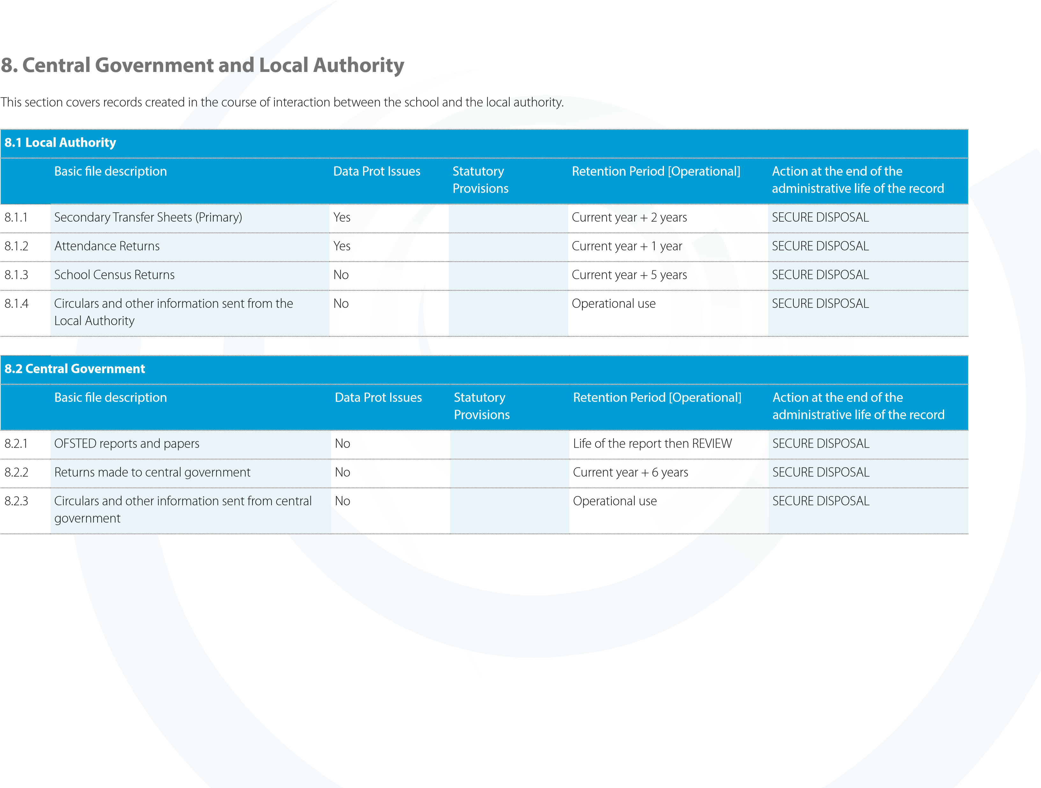
Policy / Version Date | Summary of change | Contact | Implementation Date | Review Date
May 2019 | Combination of previous e-safety policies in line with GDPR regs | S Marshall | May 2019 | May 2020

